# WINNING SPACE RACE WITH DATA SCIENCE

**A Thesis Submitted**

**In Partial Fulfilment of the** **Requirements**

**for the Degree of**

**MASTER OF COMPUTER APPLICATION**

**in**

**Data Science**

**by**

**SACHIN RATHI**

**(Enrolment No: 190029014005172)**

**Under the Supervision of**

**Ms. Vidushi**

**(ASSISTANT PROFESSOR)**

**KIET Group of institutions, Delhi-NCR, Ghaziabad**



## to the

**FACULTY OF COMPUTER APPLICATIONS**

**DR. APJ ABDUL KALAM TECHNICAL UNIVERSITY**

**LUCKNOW**

**(Formerly Uttar Pradesh Technical University, Lucknow)**

**June, 2022**

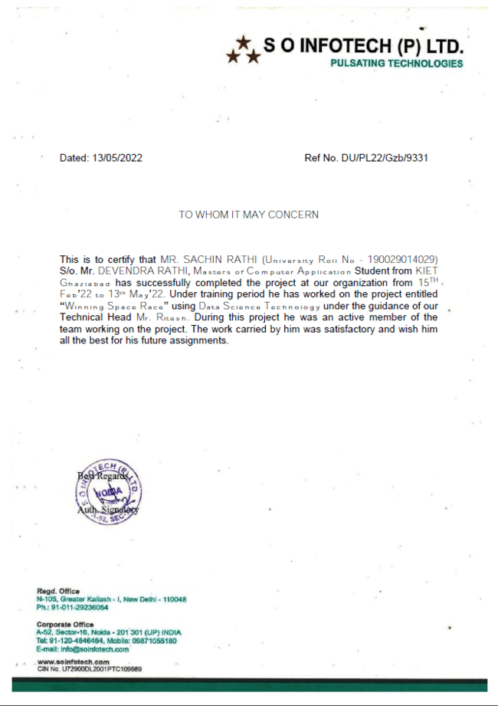

### **DECLARATION**

I hereby declare that the work presented in this report entitled “Winning Space Race with Data Science", was carried out by me. I have not submitted the matter embodied in this report for the award of any other degree or diploma of any other University or Institute. I have given due credit to the original authors/sources for all the words, ideas, diagrams, graphics, computer programs, experiments, results, that are not my original contribution. I have used quotation marks to identify verbatim sentences and given credit to the original authors/sources.

I affirm that no portion of my work is plagiarized, and the experiments and results reported in the report are not manipulated. In the event of a complaint of plagiarism and the manipulation of the experiments and results, I shall be fully responsible and answerable.

Name : Sachin Rathi

Enrol. No.: 190029014005172

Field : MCA 6th Sem.

**(Candidate Signature)**

**Sachin Rathi**

## CERTIFICATE

Certified that **Sachin Rathi (Enrolment No. 190029014005172)** have carried out the project work having “Winning Space Race with Data Science**” for** Master of Computer Applications from Dr. A.P.J. Abdul Kalam Technical University (AKTU**)**, Technical University, Lucknow under my supervision. The project report embodies original work, and studies are carried out by the student himself/herself and the contents of the project report do not form the basis for the award of any other degree to the candidate or to anybody else from this or any other University/Institution.

**Date: June 2022**

**Sachin Rathi**

**University Roll No: 1900290140029**

This is to certify that the above statement made by the candidate is correct to the best of my knowledge.

**Date: June 2022**

**Ms. Vidushi**

**Assistant Professor**

**Department of Computer Applications**

**KIET Group of Institutions, Ghaziabad**

**Signature of Internal Examiner Signature of External Examiner**

**Dr. Ajay Shrivastava**

**Head, Department of Computer Applications**

**KIET Group of Institutions, Ghaziabad**

**// Title**

**// Your name**

**ABSTRACT**

This project will give you a taste of what data scientists go through in real life when working with real datasets. You will assume the role of a Data Scientist working for a start-up intending to compete with SpaceX, and in the process follow the Data Science methodology involving data collection, data wrangling, exploratory data analysis, data visualization, model development, model evaluation, and reporting your results to stakeholders.

In this project, we will predict if the Falcon 9 first stage will land successfully. SpaceX advertises Falcon 9 rocket launches on its website, with a cost of 62 million dollars; other providers cost upward of 165 million dollars each, much of the savings is because SpaceX can reuse the first stage. Therefore, if we can determine if the first stage will land, we can determine the cost of a launch. This information can be used if an alternate company wants to bid against SpaceX for a rocket launch. In this module, you will be provided with an overview of the problem and the tools you need to complete the course.



Figure Winning Space Race with Data Science

## ACKNOWLEDGEMENTS

Success in life is never attained single headedly. My deepest gratitude goes to my thesis supervisor, **Ms. Vidushi for** his guidance, help and encouragement throughout my research work. Their enlightening ideas, comments, and suggestions.

Words are not enough to express my gratitude to **Dr. Ajay Kumar Shrivastava, Professor and Head, Department of Computer Applications**, for his insightful comments and administrative help at various occasions.

Fortunately, I have many understanding friends, who have helped me a lot on many critical conditions.

Finally, my sincere thanks go to my family members and all those who have directly and indirectly provided me moral support and other kind of help. Without their support, completion of this work would not have been possible in time. They keep my life filled with enjoyment and happiness.

**Sachin Rathi**

**1900290140029**

**MCA 6th Sem.**

Contents

WINNING SPACE RACE WITH DATA SCIENCE 1

to the 1

**DECLARATION** 3

CERTIFICATE 4

ACKNOWLEDGEMENTS 6

1️⃣ Chapter 1: Data Collection and Wrangling 13

SpaceX Falcon 9 first stage Landing Prediction 13

Lab 1: Collecting the data 13

Objectives 13

Import Libraries and Define Auxiliary Functions 13

**Task 1: Request and parse the SpaceX launch data using the GET request** 15

**Task 2: Filter the data frame to only include Falcon 9 launches** 18

Data Wrangling 18

**Task 3: Dealing with Missing Values** 19

Authors 19

Change Log 20

Space X Falcon 9 First Stage Landing Prediction 21

Web scraping Falcon 9 and Falcon Heavy Launches Records from Wikipedia 21

Objectives 21

**TASK 1: Request the Falcon9 Launch Wiki page from its URL** 23

**TASK 2: Extract all column/variable names from the HTML table header** 23

TASK 3: Create a data frame by parsing the launch HTML tables 24

Authors 27

Change Log 27

Space X Falcon 9 First Stage Landing Prediction 28

Lab 2: Data wrangling 28

Objectives 28

Import Libraries and Define Auxiliary Functions 28

**Data Analysis** 29

**TASK 1: Calculate the number of launches on each site** 30

**TASK 2: Calculate the number and occurrence of each orbit** 32

**TASK 3: Calculate the number and occurrence of mission outcome per orbit type** 32

**TASK 4: Create a landing outcome label from Outcome column** 33

Authors 34

Change Log 34

2️⃣ Chapter 2: Exploratory Data Analysis (EDA) 35

Assignment: SQL Notebook for Peer Assignment 35

Introduction 35

Overview of the Dataset 35

Download the datasets 35

Store the dataset in database table 35

Connect to the database 39

Tasks 46

**Task 1** 46

**Task 2** 47

**Task 3** 48

**Task 4** 49

**Task 5** 49

**Task 6** 49

**Task 7** 50

**Task 8** 50

**Task 9** 51

**Task 10** 52

Author(s) 53

Other Contributors 53

Change log 53

SpaceX Falcon 9 First Stage Landing Prediction 54

Assignment: Exploring and Preparing Data 54

Objectives 54

**Import Libraries and Define Auxiliary Functions** 54

Exploratory Data Analysis 55

**TASK 1: Visualize the relationship between Flight Number and Launch Site** 57

**TASK 2: Visualize the relationship between Payload and Launch Site** 57

**TASK 3: Visualize the relationship between success rate of each orbit type** 58

Explain the patterns - which orbits have high sucess rate. 58

**TASK 4: Visualize the relationship between FlightNumber and Orbit type** 58

**TASK 5: Visualize the relationship between Payload and Orbit type** 59

**TASK 6: Visualize the launch success yearly trend** 59

Features Engineering 61

**TASK 7: Create dummy variables to categorical columns** 62

**TASK 8: Cast all numeric columns to float64** 63

Authors 65

Change Log 66

3️⃣Chapter 3: Interactive Visual Analytics and Dashboard 67

Launch Sites Locations Analysis with Folium 67

Objectives 67

Task 1: Mark all launch sites on a map 68

My Own Custom Functions for Markers 70

Task 2: Mark the success/failed launches for each site on the map 72

TASK 3: Calculate the distances between a launch site to its proximities 76

Next Steps: 80

Authors 81

Other Contributors 81

Change Log 81

4️⃣ Chapter 4: Predictive Analysis (Classification) 86

Space X Falcon 9 First Stage Landing Prediction 86

Assignment: Machine Learning Prediction 86

Objectives 86

Import Libraries and Define Auxiliary Functions 86

Load the dataframe 87

TASK 1 93

TASK 2 93

TASK 3 93

TASK 4 93

TASK 5 94

TASK 6 94

TASK 7 95

TASK 8 96

TASK 9 96

TASK 10 97

TASK 11 97

TASK 12 98

Authors 100

Change Log 100

5️⃣ Chapter 5: Present Your Data-Driven Insights 101

💫 Out of the Box Thinking 102

⛏️ Built With 106

📚 Extra Study Materials 106

Refererences……………………………………………………………………................107

CurriculamVitae…………………………………………………………………………..108

**Chapter 0: Introduction**

The commercial space age is here, companies are making space travel affordable for everyone. Virgin Galactic is providing suborbital spaceflights. Rocket Lab is a small satellite provider. Blue Origin manufactures sub-orbital and orbital reusable rockets. Perhaps the most successful is SpaceX. SpaceX’s accomplishments include Sending spacecraft to the International Space Station. Starlink, a satellite internet constellation providing satellite Internet access. Sending manned missions to Space. One reason SpaceX can do this is the rocket launches are relatively inexpensive. SpaceX advertises Falcon 9 rocket launches on its website with a cost of 62 million dollars; other providers cost upwards of 165 million dollars each, much of the savings is because SpaceX can reuse the first stage.

[](https://github.com/sachinrathi1997/SpaceX_DS_Project/blob/main/images/fail.gif)

Figure Fail.gif

[](https://github.com/sachinrathi1997/SpaceX_DS_Project/blob/main/images/success.gif)

Figure Success.gif

In this capstone, I take the role of a data scientist working for a new rocket company. Space Y that would like to compete with SpaceX founded by Billionaire industrialist Alon Musk. My job is to determine the price of each launch. I must do this by gathering information about Space X and creating dashboards for my team. I also determine if SpaceX will reuse the first stage. Instead of using rocket science to determine if the first stage will land successfully, I will train a machine learning model and use public information to predict if SpaceX will reuse the first stage.

## 1️⃣ Chapter 1: Data Collection and Wrangling

**1.1: [Collecting the Data via API](https://github.com/sachinrathi1997/SpaceX_DS_Project/blob/main/jupyter-labs-spacex-data-collection-api.ipynb)**

# ****SpaceX Falcon 9 first stage Landing Prediction****

# Lab 1: Collecting the data

In this capstone, we will predict if the Falcon 9 first stage will land successfully. SpaceX advertises Falcon 9 rocket launches on its website with a cost of 62 million dollars; other providers cost upward of 165 million dollars each, much of the savings is because SpaceX can reuse the first stage. Therefore, if we can determine if the first stage will land, we can determine the cost of a launch. This information can be used if an alternate company wants to bid against SpaceX for a rocket launch. In this lab, you will collect and make sure the data is in the correct format from an API. The following is an example of a successful and launch.

Several examples of an unsuccessful landing are shown here:

Most unsuccessful landings are planned. Space X performs a controlled landing in the oceans.

## Objectives

In this lab, you will make a get request to the SpaceX API. You will also do some basic data wrangling and formatting.

* Request to the SpaceX API
* Clean the requested data

## Import Libraries and Define Auxiliary Functions

We will import the following libraries into the lab

In [1]:

*# Requests allows us to make HTTP requests which we will use to get data from an API*

**import** requests

*# Pandas is a software library written for the Python programming language for data manipulation and analysis.*

**import** pandas **as** pd

*# NumPy is a library for the Python programming language, adding support for large, multi-dimensional arrays and matrices, along with a large collection of high-level mathematical functions to operate on these arrays*

**import** numpy **as** np

*# Datetime is a library that allows us to represent dates*

**import** datetime

*# Setting this option will print all collumns of a dataframe*

pd**.**set_option('display.max_columns', **None**)

*# Setting this option will print all of the data in a feature*

pd**.**set_option('display.max_colwidth', **None**)

Below we will define a series of helper functions that will help us use the API to extract information using identification numbers in the launch data.

From the rocket column we would like to learn the booster’s name.

In [2]:

*# Takes the dataset and uses the rocket column to call the API and append the data to the list*

**def** getBoosterVersion(data):

**for** x **in** data['rocket']:

response **=** requests**.**get("https://api.spacexdata.com/v4/rockets/"**+**str(x))**.**json()

BoosterVersion**.**append(response['name'])

From the launchpad we would like to know the name of the launch site being used, the longitude, and the latitude.

In [3]:

*# Takes the dataset and uses the launchpad column to call the API and append the data to the list*

**def** getLaunchSite(data):

**for** x **in** data['launchpad']:

response **=** requests**.**get("https://api.spacexdata.com/v4/launchpads/"**+**str(x))**.**json()

Longitude**.**append(response['longitude'])

Latitude**.**append(response['latitude'])

LaunchSite**.**append(response['name'])

From the payload we would like to learn the mass of the payload and the orbit that it is going to.

In [4]:

*# Takes the dataset and uses the payloads column to call the API and append the data to the lists*

**def** getPayloadData(data):

**for** load **in** data['payloads']:

response **=** requests**.**get("https://api.spacexdata.com/v4/payloads/"**+**load)**.**json()

PayloadMass**.**append(response['mass_kg'])

Orbit**.**append(response['orbit'])

From cores we would like to learn the outcome of the landing, the type of the landing, number of flights with that core, whether grid fins were used, whether the core is reused, whether legs were used, the landing pad used, the block of the core which is a number used to separate version of cores, the number of times this specific core has been reused, and the serial of the core.

In [5]:

*# Takes the dataset and uses the cores column to call the API and append the data to the lists*

**def** getCoreData(data):

**for** core **in** data['cores']:

**if** core['core'] **!=** **None**:

response **=** requests**.**get("https://api.spacexdata.com/v4/cores/"**+**core['core'])**.**json()

Block**.**append(response['block'])

ReusedCount**.**append(response['reuse_count'])

Serial**.**append(response['serial'])

**else**:

Block**.**append(**None**)

ReusedCount**.**append(**None**)

Serial**.**append(**None**)

Outcome**.**append(str(core['landing_success'])**+**' '**+**str(core['landing_type']))

Flights**.**append(core['flight'])

GridFins**.**append(core['gridfins'])

Reused**.**append(core['reused'])

Legs**.**append(core['legs'])

LandingPad**.**append(core['landpad'])

Now let's start requesting rocket launch data from SpaceX API with the following URL:

In [6]:

spacex_url**=**"https://api.spacexdata.com/v4/launches/past"

In [7]:

response **=** requests**.**get(spacex_url)

Check the content of the response

In [8]:

print(response**.**content)

### **Task 1: Request and parse the SpaceX launch data using the GET request**

To make the requested JSON results more consistent, we will use the following static response object for this project:

In [9]:

static_json_url**=**'https://cf-courses-data.s3.us.cloud-object-storage.appdomain.cloud/IBM-DS0321EN-SkillsNetwork/datasets/API_call_spacex_api.json'

We should see that the request was successful with the 200-status response code

In [10]:

response**.**status_code

Out[10]:

200

Now we decode the response content as a Json using .json() and turn it into a Pandas data frame using .Json normalize()

In [14]:

*# Use json_normalize meethod to convert the json result into a dataframe*

json_data **=** requests**.**get(static_json_url)**.**json()

data**=**pd**.**json_normalize(json_data)

Using the data frame data print the first 5 rows

In [15]:

*# Get the head of the dataframe*

data**.**head()

You will notice that a lot of the data are IDs. For example, the rocket column has no information about the rocket just an identification number.

We will now use the API again to get information about the launches using the IDs given for each launch. Specifically, we will be using columns rocket, payloads, launchpad, and cores.

In [16]:

*# Lets take a subset of our dataframe keeping only the features we want and the flight number, and date_utc.*

data **=** data[['rocket', 'payloads', 'launchpad', 'cores', 'flight_number', 'date_utc']]

*# We will remove rows with multiple cores because those are falcon rockets with 2 extra rocket boosters and rows that have multiple payloads in a single rocket.*

data **=** data[data['cores']**.**map(len)**==**1]

data **=** data[data['payloads']**.**map(len)**==**1]

*# Since payloads and cores are lists of size 1 we will also extract the single value in the list and replace the feature.*

data['cores'] **=** data['cores']**.**map(**lambda** x : x[0])

data['payloads'] **=** data['payloads']**.**map(**lambda** x : x[0])

*# We also want to convert the date_utc to a datetime datatype and then extracting the date leaving the time*

data['date'] **=** pd**.**to_datetime(data['date_utc'])**.**dt**.**date

*# Using the date we will restrict the dates of the launches*

data **=** data[data['date'] **<=** datetime**.**date(2020, 11, 13)]

* From the rocket we would like to learn the booster name
* From the payload we would like to learn the mass of the payload and the orbit that it is going to
* From the launchpad we would like to know the name of the launch site being used, the longitude, and the latitude.
* From cores we would like to learn the outcome of the landing, the type of the landing, number of flights with that core, whether grid fins were used, whether the core is reused, whether legs were used, the landing pad used, the block of the core which is a number used to separate version of cores, the number of times this specific core has been reused, and the serial of the core.

The data from these requests will be stored in lists and will be used to create a new data frame.

In [17]:

*#Global variables*

BoosterVersion **=** []

PayloadMass **=** []

Orbit **=** []

LaunchSite **=** []

Outcome **=** []

Flights **=** []

GridFins **=** []

Reused **=** []

Legs **=** []

LandingPad **=** []

Block **=** []

ReusedCount **=** []

Serial **=** []

Longitude **=** []

Latitude **=** []

These functions will apply the outputs globally to the above variables. Let's take a looks at BoosterVersion variable. Before we apply getBoosterVersion the list is empty:

In [18]:

BoosterVersion

Out [18]:

[]

Now, let's apply getBoosterVersion function method to get the booster version

In [19]:

*# Call getBoosterVersion*

getBoosterVersion(data)

the list has now been updated

In [20]:

BoosterVersion[0:5]

Out [20]:

['Falcon 1', 'Falcon 1', 'Falcon 1', 'Falcon 1', 'Falcon 9']

we can apply the rest of the functions here:

In [21]:

*# Call getLaunchSite*

getLaunchSite(data)

In [22]:

*# Call getPayloadData*

getPayloadData(data)

In [23]:

*# Call getCoreData*

getCoreData(data)

Finally let’s construct our dataset using the data we have obtained. We combine the columns into a dictionary.

In [24]:

launch_dict **=** {'FlightNumber': list(data['flight_number']),

'Date': list(data['date']),

'BoosterVersion':BoosterVersion,

'PayloadMass':PayloadMass,

'Orbit':Orbit,

'LaunchSite':LaunchSite,

'Outcome':Outcome,

'Flights':Flights,

'GridFins':GridFins,

'Reused':Reused,

'Legs':Legs,

'LandingPad':LandingPad,

'Block':Block,

'ReusedCount':ReusedCount,

'Serial':Serial,

'Longitude': Longitude,

'Latitude': Latitude}

Then, we need to create a Pandas data frame from the dictionary launch_dict.

In [25]:

*# Create a data from launch_dict*

launch_df **=** pd**.**DataFrame([launch_dict])

Show the summary of the data frame

In [26]:

*# Show the head of the dataframe*

launch_df**.**head()

### **Task 2: Filter the data frame to only include Falcon 9 launches**

Finally, we will remove the Falcon 1 launches keeping only the Falcon 9 launches. Filter the data frame using the Booster Version column to only keep the Falcon 9 launches. Save the filtered data to a new data frame called data_falcon9.

In [27]:

*# Hint data['BoosterVersion']!='Falcon 1'*

data_falcon9 **=** launch_df[launch_df['BoosterVersion'] **!=** 'Falcon 9']

data_falcon9

Now that we have removed some values, we should reset the FlgihtNumber column

In [28]:

data_falcon9**.**loc[:,'FlightNumber'] **=** list(range(1, data_falcon9**.**shape[0]**+**1))

data_falcon9

## Data Wrangling

We can see below that some of the rows are missing values in our dataset.

In [29]:

data_falcon9**.**isnull()**.**sum()

Out[29]:

FlightNumber 0

Date 0

BoosterVersion 0

PayloadMass 0

Orbit 0

LaunchSite 0

Outcome 0

Flights 0

GridFins 0

Reused 0

Legs 0

LandingPad 0

Block 0

ReusedCount 0

Serial 0

Longitude 0

Latitude 0

dtype: int64

Before we can continue, we must deal with these missing values. The Landing Pad column will retain No values to represent when landing pads were not used.

### **Task 3: Dealing with Missing Values**

Calculate below the mean for the Payload Mass using the. mean (). Then use the mean and the. replace () function to replace np.nan values in the data with the mean you calculated.

In [30]:

*# Calculate the mean value of PayloadMass column*

PayloadMass **=** pd**.**DataFrame(data_falcon9['PayloadMass']**.**values**.**tolist())**.**mean(1)

*# Replace the np.nan values with its mean value*

rows **=** data_falcon9['PayloadMass']**.**values**.**tolist()[0]

df_rows **=** pd**.**DataFrame(rows)

df_rows **=** df_rows**.**replace(np**.**nan, PayloadMass)

data_falcon9['PayloadMass'][0] **=** df_rows**.**values

data_falcon9**.**head()

*# Replace the np.nan values with its mean value*

You should see the number of missing values of the PayLoadMass change to zero.

In [31]:

data_falcon9**.**to_csv('dataset_part\_1.csv', index**=False**)

Now we should have no missing values in our dataset except for in Landing Pad.

We can now export it to a **CSV** for the next section, but to make the answers consistent, in the next lab we will provide data in a pre-selected date range.

data_falcon9.to_csv('dataset_part\_1.csv', index=False)

## Authors

[Joseph Sant Arcangelo](https://www.linkedin.com/in/joseph-s-50398b136/?utm_medium=Exinfluencer&utm_source=Exinfluencer&utm_content=000026UJ&utm_term=10006555&utm_id=NA-SkillsNetwork-Channel-SkillsNetworkCoursesIBMDS0321ENSkillsNetwork26802033-2021-01-01) has a PhD in Electrical Engineering, his research focused on using machine learning, signal processing, and computer vision to determine how videos impact human cognition. Joseph has been working for IBM since he completed his PhD.

## Change Log

Table : Week 1.1 Change log

| **Date (YYYY-MM-DD)** | **Version** | **Changed By** | **Change Description** |
| --- | --- | --- | --- |
| 2020-09-20 | 1.1 | Joseph | get result each time you run |
| 2020-09-20 | 1.1 | Azim | Created Part 1 Lab using SpaceX API |
| 2020-09-20 | 1.0 | Joseph | Modified Multiple Areas |

**1.2: [Collecting the Data via Web Scraping](https://github.com/sachinrathi1997/SpaceX_DS_Project/blob/main/jupyter-labs-webscraping.ipynb)**

# ****Space X Falcon 9 First Stage Landing Prediction****

## Web scraping Falcon 9 and Falcon Heavy Launches Records from Wikipedia

In this lab, you will be performing web scraping to collect Falcon 9 historical launch records from a Wikipedia page titled List of Falcon 9 and Falcon Heavy launches

[https://en.wikipedia.org/wiki/List_of_Falcon\_9\_and_Falcon_Heavy_launches](https://en.wikipedia.org/wiki/List_of_Falcon%5C_9%5C_and_Falcon_Heavy_launches?utm_medium=Exinfluencer&utm_source=Exinfluencer&utm_content=000026UJ&utm_term=10006555&utm_id=NA-SkillsNetwork-Channel-SkillsNetworkCoursesIBMDS0321ENSkillsNetwork26802033-2021-01-01)

Falcon 9 first stage will land successfully

Several examples of an unsuccessful landing are shown here:

More specifically, the launch records are stored in a HTML table shown below:

## Objectives

Web scrap Falcon 9 launch records with Beautiful Soup:

* Extract a Falcon 9 launch records HTML table from Wikipedia
* Parse the table and convert it into a Pandas data frame

First let's import required packages for this lab

In [1]:

**!**pip3 install beautifulsoup4

**!**pip3 install requests

Requirement already satisfied: beautifulsoup4 in /home/jupyterlab/conda/envs/python/lib/python3.7/site-packages (4.11.1)

Requirement already satisfied: soupsieve>1.2 in /home/jupyterlab/conda/envs/python/lib/python3.7/site-packages (from beautifulsoup4) (2.3.2.post1)

Requirement already satisfied: requests in /home/jupyterlab/conda/envs/python/lib/python3.7/site-packages (2.27.1)

Requirement already satisfied: certifi>=2017.4.17 in /home/jupyterlab/conda/envs/python/lib/python3.7/site-packages (from requests) (2021.10.8)

Requirement already satisfied: urllib3<1.27,>=1.21.1 in /home/jupyterlab/conda/envs/python/lib/python3.7/site-packages (from requests) (1.26.9)

Requirement already satisfied: idna<4,>=2.5 in /home/jupyterlab/conda/envs/python/lib/python3.7/site-packages (from requests) (3.3)

Requirement already satisfied: charset-normalizer~=2.0.0 in /home/jupyterlab/conda/envs/python/lib/python3.7/site-packages (from requests) (2.0.12)

In [7]:

**import** sys

**import** requests

**from** bs4 **import** BeautifulSoup

**import** re

**import** unicodedata

**import** pandas **as** pd

and we will provide some helper functions for you to process web scraped HTML table

In [8]:

**def** date_time(table_cells):

"""

This function returns the data and time from the HTML table cell

Input: the element of a table data cell extracts extra row

"""

**return** [data_time**.**strip() **for** data_time **in** list(table_cells**.**strings)][0:2]

**def** booster_version(table_cells):

"""

This function returns the booster version from the HTML table cell

Input: the element of a table data cell extracts extra row

"""

out**=**''**.**join([booster_version **for** i,booster_version **in** enumerate( table_cells**.**strings) **if** i**%2**==0][0:-1])

**return** out

**def** landing_status(table_cells):

"""

This function returns the landing status from the HTML table cell

Input: the element of a table data cell extracts extra row

"""

out**=**[i **for** i **in** table_cells**.**strings][0]

**return** out

**def** get_mass(table_cells):

mass**=**unicodedata**.**normalize("NFKD", table_cells**.**text)**.**strip()

**if** mass:

mass**.**find("kg")

new_mass**=**mass[0:mass**.**find("kg")**+**2]

**else**:

new_mass**=**0

**return** new_mass

**def** extract_column_from_header(row):

"""

This function returns the landing status from the HTML table cell

Input: the element of a table data cell extracts extra row

"""

**if** (row**.**br):

row**.**br**.**extract()

**if** row**.**a:

row**.**a**.**extract()

**if** row**.**sup:

row**.**sup**.**extract()

colunm_name **=** ' '**.**join(row**.**contents)

*# Filter the digit and empty names*

**if** **not**(colunm_name**.**strip()**.**isdigit()):

colunm_name **=** colunm_name**.**strip()

**return** colunm_name

To keep the lab tasks consistent, you will be asked to scrape the data from a snapshot of the List of Falcon 9 and Falcon Heavy launches Wiki page updated on 9th June 2021

In [9]:

static_url **=** "https://en.wikipedia.org/w/index.php?title=List_of_Falcon_9_and_Falcon_Heavy_launches&oldid=1027686922"

Next, request the HTML page from the above URL and get a response object

### **TASK 1: Request the Falcon9 Launch Wiki page from its URL**

First, let's perform an HTTP GET method to request the Falcon9 Launch HTML page, as an HTTP response.

In [14]:

*# use requests.get() method with the provided static_url*

*# assign the response to a object*

html_data **=** requests**.**get(static_url)

html_data**.**status_code

Out[14]:

200

Create a BeautifulSoup object from the HTML response

In [15]:

*# Use BeautifulSoup() to create a BeautifulSoup object from a response text content*

soup **=** BeautifulSoup(html_data**.**text, 'html.parser')

Print the page title to verify if the BeautifulSoup object was created properly

In [16]:

*# Use soup.title attribute*

soup**.**title

Out[16]:

<title>List of Falcon 9 and Falcon Heavy launches - Wikipedia</title>

### **TASK 2: Extract all column/variable names from the HTML table header**

Next, we want to collect all relevant column names from the HTML table header

Let's try to find all tables on the wiki page first. If you need to refresh your memory about BeautifulSoup, please check the external reference link towards the end of this lab

In [17]:

*# Use the find_all function in the BeautifulSoup object, with element type `table`*

*# Assign the result to a list called `html_tables`*

html_tables **=** soup**.**find_all('table')

Starting from the third table is our target table contains the actual launch records.

In [18]:

*# Let's print the third table and check its content*

first_launch_table **=** html_tables[2]

print(first_launch_table)

Next, we just need to iterate through the <th> elements and apply the provided extract_column_from_header() to extract column name one by on

column_names **=** []

*# Apply find_all() function with `th` element on first_launch_table*

*# Iterate each th element and apply the provided extract_column_from_header() to get a column name*

*# Append the Non-empty column name (`if name is not None and len(name) > 0`) into a list called column_names*

**for** row **in** first_launch_table**.**find_all('th'):

names **=** extract_column_from_header(row)

column_names**.**append(names)

Check the extracted column names

In [22]:

print(column_names)

['Flight No.', 'Date and time ( )', '', 'Launch site', 'Payload', 'Payload mass', 'Orbit', 'Customer', 'Launch outcome', '', None, None, None, None, None, None, None]

## TASK 3: Create a data frame by parsing the launch HTML tables

We will create an empty dictionary with keys from the extracted column names in the previous task. Later, this dictionary will be converted into a Pandas data frame

In [32]:

launch_dict**=** dict**.**fromkeys(column_names)

*# Remove an irrelvant column*

**del** launch_dict['Date and time ( )']

*# Let's initial the launch_dict with each value to be an empty list*

launch_dict['Flight No.'] **=** []

launch_dict['Launch site'] **=** []

launch_dict['Payload'] **=** []

launch_dict['Payload mass'] **=** []

launch_dict['Orbit'] **=** []

launch_dict['Customer'] **=** []

launch_dict['Launch outcome'] **=** []

*# Added some new columns*

launch_dict['Version Booster']**=**[]

launch_dict['Booster landing']**=**[]

launch_dict['Date']**=**[]

launch_dict['Time']**=**[]

Next, we just need to fill up the launch_dict with launch records extracted from table rows.

Usually, HTML tables in Wiki pages are likely to contain unexpected annotations and other types of noises, such as reference links B0004.1[8], missing values N/A [e], inconsistent formatting, etc.

To simplify the parsing process, we have provided an incomplete code snippet below to help you to fill up the launch_dict. Please complete the following code snippet with TODOs or you can choose to write your own logic to parse all launch tables:

In [33]:

extracted_row **=** 0

*#Extract each table*

**for** table_number,table **in** enumerate(soup**.**find_all('table',"wikitable plainrowheaders collapsible")):

*# get table row*

**for** rows **in** table**.**find_all("tr"):

*#check to see if first table heading is as number corresponding to launch a number*

**if** rows**.**th:

**if** rows**.**th**.**string:

flight_number**=**rows**.**th**.**string**.**strip()

flag**=**flight_number**.**isdigit()

**else**:

flag**=False**

*#get table element*

row**=**rows**.**find_all('td')

*#if it is number save cells in a dictonary*

**if** flag:

extracted_row **+=** 1

*## Flight Number value*

*## TODO: Append the flight_number into launch_dict with key `Flight No.`*

*## print(flight_number)*

datatimelist**=**date_time(row[0])

launch_dict['Flight No.']**.**append(extracted_row)

print("flight number:",extracted_row)

*## Date value*

*## TODO: Append the date into launch_dict with key `Date`*

date **=** datatimelist[0]**.**strip(',')

launch_dict['Date']**.**append(date)

*##print(date)*

print("Date:",date)

*## Time value*

*## TODO: Append the time into launch_dict with key `Time`*

time **=** datatimelist[1]

launch_dict['Time']**.**append(time)

*## print(time)*

print("time:",time)

*## Booster version*

*## TODO: Append the bv into launch_dict with key `Version Booster`*

bv**=**booster_version(row[1])

**if** **not**(bv):

bv**=**row[1]**.**a**.**string

launch_dict['Version Booster']**.**append(bv)

print(bv)

*## Launch Site*

*## TODO: Append the bv into launch_dict with key `Launch Site`*

launch_site **=** row[2]**.**a**.**string

launch_dict['Launch site']**.**append(launch_site)

*##print(launch_site)*

print("launch site:",launch_site)

*## Payload*

*## TODO: Append the payload into launch_dict with key `Payload`*

payload **=** row[3]**.**a**.**string

launch_dict['Payload']**.**append(payload)

*##print(payload)*

print("Payload:",payload)

*## Payload Mass*

*## TODO: Append the payload_mass into launch_dict with key `Payload mass`*

payload_mass **=** get_mass(row[4])

launch_dict['Payload mass']**.**append(payload_mass)

*##print(payload)*

print("Payload mass:",payload_mass)

*## Orbit*

*## TODO: Append the orbit into launch_dict with key `Orbit`*

orbit **=** row[5]**.**a**.**string

launch_dict['Orbit']**.**append(orbit)

*##print(orbit)*

print("Orbit:",orbit)

*## Customer*

*## TODO: Append the customer into launch_dict with key `Customer`*

**try**: customer **=** row[6]**.**a**.**string

**except** AttributeError: customer **=** row[6]**.**string

launch_dict['Customer']**.**append(customer)

*##print(customer)*

print("Customer:",customer)

*## Launch outcome*

*## TODO: Append the launch_outcome into launch_dict with key `Launch outcome`*

launch_outcome **=** list(row[7]**.**strings)[0]

launch_dict['Launch outcome']**.**append(launch_outcome)

*## print(launch_outcome)*

print("Launch outcome:",launch_outcome)

*## Booster landing*

*## TODO: Append the launch_outcome into launch_dict with key `Booster landing`*

booster_landing **=** landing_status(row[8])

launch_dict['Booster landing']**.**append(booster_landing)

*## print(booster_landing)*

print("booster landing:",booster_landing)

After you have fill in the parsed launch record values into launch_dict, you can create a dataframe from it.

In [34]:

df**=**pd**.**DataFrame(launch_dict)

We can now export it to a **CSV** for the next section, but to make the answers consistent and in case you have difficulties finishing this lab.

Following labs will be using a provided dataset to make each lab independent.

In [35]:

df**.**to_csv('spacex_web_scraped.csv', index**=False**)

df.to_csv('spacex_web_scraped.csv', index=False)

## Authors

[Yan Luo](https://www.linkedin.com/in/yan-luo-96288783/?utm_medium=Exinfluencer&utm_source=Exinfluencer&utm_content=000026UJ&utm_term=10006555&utm_id=NA-SkillsNetwork-Channel-SkillsNetworkCoursesIBMDS0321ENSkillsNetwork26802033-2021-01-01)

[Nayef Abou Tayoun](https://www.linkedin.com/in/nayefaboutayoun/?utm_medium=Exinfluencer&utm_source=Exinfluencer&utm_content=000026UJ&utm_term=10006555&utm_id=NA-SkillsNetwork-Channel-SkillsNetworkCoursesIBMDS0321ENSkillsNetwork26802033-2021-01-01)

## Change Log

Table : Week 1.2 Change log

| **Date (YYYY-MM-DD)** | **Version** | **Changed By** | **Change Description** |
| --- | --- | --- | --- |
| 2021-06-09 | 1.0 | Yan Luo | Tasks updates |
| 2020-11-10 | 1.0 | Nayef | Created the initial version |

**1.3: [Data Wrangling](https://github.com/sachinrathi1997/SpaceX_DS_Project/blob/main/labs-jupyter-spacex-Data%2520wrangling.ipynb)**

# ****Space X Falcon 9 First Stage Landing Prediction****

## Lab 2: Data wrangling

Estimated time needed: **60** minutes

In this lab, we will perform some Exploratory Data Analysis (EDA) to find some patterns in the data and determine what would be the label for training supervised models.

In the data set, there are several different cases where the booster did not land successfully. Sometimes a landing was attempted but failed due to an accident; for example, True Ocean means the mission outcome was successfully landed to a specific region of the ocean while False Ocean means the mission outcome was unsuccessfully landed to a specific region of the ocean. True RTLS means the mission outcome was successfully landed to a ground pad False RTLS means the mission outcome was unsuccessfully landed to a ground pad.True ASDS means the mission outcome was successfully landed on a drone ship False ASDS means the mission outcome was unsuccessfully landed on a drone ship.

In this lab we will mainly convert those outcomes into Training Labels with 1 means the booster successfully landed 0 means it was unsuccessful.

Falcon 9 first stage will land successfully

Several examples of an unsuccessful landing are shown here:

## Objectives

Perform exploratory Data Analysis and determine Training Labels

* Exploratory Data Analysis
* Determine Training Labels

## Import Libraries and Define Auxiliary Functions

We will import the following libraries.

In [1]:

*# Pandas is a software library written for the Python programming language for data manipulation and analysis.*

**import** pandas **as** pd

*#NumPy is a library for the Python programming language, adding support for large, multi-dimensional arrays and matrices, along with a large collection of high-level mathematical functions to operate on these arrays*

**import** numpy **as** np

### **Data Analysis**

Load Space X dataset, from last section.

In [2]:

df**=**pd**.**read_csv("https://cf-courses-data.s3.us.cloud-object-storage.appdomain.cloud/IBM-DS0321EN-SkillsNetwork/datasets/dataset_part_1.csv")

df**.**head(10)

Identify and calculate the percentage of the missing values in each attribute

In [3]:

df**.**isnull()**.**sum()**/**df**.**count()**\***100

FlightNumber 0.000

Date 0.000

BoosterVersion 0.000

PayloadMass 0.000

Orbit 0.000

LaunchSite 0.000

Outcome 0.000

Flights 0.000

GridFins 0.000

Reused 0.000

Legs 0.000

LandingPad 40.625

Block 0.000

ReusedCount 0.000

Serial 0.000

Longitude 0.000

Latitude 0.000

dtype: float64

Identify which columns are numerical and categorical:

In [4]:

df**.**dtypes

Out[4]:

FlightNumber int64

Date object

BoosterVersion object

PayloadMass float64

Orbit object

LaunchSite object

Outcome object

Flights int64

GridFins bool

Reused bool

Legs bool

LandingPad object

Block float64

ReusedCount int64

Serial object

Longitude float64

Latitude float64

dtype: object

### **TASK 1: Calculate the number of launches on each site**

The data contains several Space X launch facilities: [Cape Canaveral Space](https://en.wikipedia.org/wiki/List_of_Cape_Canaveral_and_Merritt_Island_launch_sites?utm_medium=Exinfluencer&utm_source=Exinfluencer&utm_content=000026UJ&utm_term=10006555&utm_id=NA-SkillsNetwork-Channel-SkillsNetworkCoursesIBMDS0321ENSkillsNetwork26802033-2021-01-01) Launch Complex 40 **VAFB SLC 4E**, Vandenberg Air Force Base Space Launch Complex 4E **(SLC-4E)**, Kennedy Space Centre Launch Complex 39A **KSC LC 39A**.The location of each Launch Is placed in the column Launch Site

Next, let's see the number of launches for each site.

Use the method value_counts() on the column LaunchSite to determine the number of launches on each site:

In [5]:

*# Apply value_counts() on column LaunchSite*

df['LaunchSite']**.**value_counts()

Out[5]:

CCAFS SLC 40 55

KSC LC 39A 22

VAFB SLC 4E 13

Name: LaunchSite, dtype: int64

**Each launch aims to a dedicated orbit, and here are some common orbit types:**

* **LEO**: Low Earth orbit (LEO)is an Earth-centred orbit with an altitude of 2,000 km (1,200 mi) or less (approximately one-third of the radius of Earth),[1] or with at least 11.25 periods per day (an orbital period of 128 minutes or less) and an eccentricity less than 0.25.[2] Most of the manmade objects in outer space are in LEO [\[1]](https://en.wikipedia.org/wiki/Low_Earth_orbit?utm_medium=Exinfluencer&utm_source=Exinfluencer&utm_content=000026UJ&utm_term=10006555&utm_id=NA-SkillsNetwork-Channel-SkillsNetworkCoursesIBMDS0321ENSkillsNetwork26802033-2021-01-01).
* **VLEO**: Very Low Earth Orbits (VLEO) can be defined as the orbits with a mean altitude below 450 km. Operating in these orbits can provide a number of benefits to Earth observation spacecraft as the spacecraft operates closer to the observation[\[2]](https://www.researchgate.net/publication/271499606_Very_Low_Earth_Orbit_mission_concepts_for_Earth_Observation_Benefits_and_challenges?utm_medium=Exinfluencer&utm_source=Exinfluencer&utm_content=000026UJ&utm_term=10006555&utm_id=NA-SkillsNetwork-Channel-SkillsNetworkCoursesIBMDS0321ENSkillsNetwork26802033-2021-01-01).
* **GTO** A geosynchronous orbit is a high Earth orbit that allows satellites to match Earth's rotation. Located at 22,236 miles (35,786 kilometres) above Earth's equator, this position is a valuable spot for monitoring weather, communications and surveillance. Because the satellite orbits at the same speed that the Earth is turning, the satellite seems to stay in place over a single longitude, though it may drift north to south,” NASA wrote on its Earth Observatory website [\[3]](https://www.space.com/29222-geosynchronous-orbit.html?utm_medium=Exinfluencer&utm_source=Exinfluencer&utm_content=000026UJ&utm_term=10006555&utm_id=NA-SkillsNetwork-Channel-SkillsNetworkCoursesIBMDS0321ENSkillsNetwork26802033-2021-01-01).
* **SSO (or SO)**: It is a Sun-synchronous orbit also called a Heli synchronous orbit is a nearly polar orbit around a planet, in which the satellite passes over any given point of the planet's surface at the same local mean solar time [[4]](https://en.wikipedia.org/wiki/Sun-synchronous_orbit?utm_medium=Exinfluencer&utm_source=Exinfluencer&utm_content=000026UJ&utm_term=10006555&utm_id=NA-SkillsNetwork-Channel-SkillsNetworkCoursesIBMDS0321ENSkillsNetwork26802033-2021-01-01).
* **ES-L1**:At the Lagrange points the gravitational forces of the two large bodies cancel out in such a way that a small object placed in orbit there is in equilibrium relative to the centre of mass of the large bodies. L1 is one such point between the sun and the earth [\[5]](https://en.wikipedia.org/wiki/Lagrange_point?utm_medium=Exinfluencer&utm_source=Exinfluencer&utm_content=000026UJ&utm_term=10006555&utm_id=NA-SkillsNetwork-Channel-SkillsNetworkCoursesIBMDS0321ENSkillsNetwork26802033-2021-01-01#L1_point) .
* **HEO** A highly elliptical orbit, is an elliptic orbit with high eccentricity, usually referring to one around Earth [\[6]](https://en.wikipedia.org/wiki/Highly_elliptical_orbit?utm_medium=Exinfluencer&utm_source=Exinfluencer&utm_content=000026UJ&utm_term=10006555&utm_id=NA-SkillsNetwork-Channel-SkillsNetworkCoursesIBMDS0321ENSkillsNetwork26802033-2021-01-01).
* **ISS**A modular space station (habitable artificial satellite) in low Earth orbit. It is a multinational collaborative project between five participating space agencies: NASA (United States), Ros cosmos (Russia), JAXA (Japan), ESA (Europe), and CSA (Canada)[\[7]](https://en.wikipedia.org/wiki/International_Space_Station?utm_medium=Exinfluencer&utm_source=Exinfluencer&utm_content=000026UJ&utm_term=10006555&utm_id=NA-SkillsNetwork-Channel-SkillsNetworkCoursesIBMDS0321ENSkillsNetwork26802033-2021-01-01)
* **MEO**Geocentric orbits ranging in altitude from 2,000 km (1,200 mi) to just below geosynchronous orbit at 35,786 kilometres (22,236 mi). Also known as an intermediate circular orbit. These are "most commonly at 20,200 kilometres (12,600 mi), or 20,650 kilometres (12,830 mi), with an orbital period of 12 hours [\[8]](https://en.wikipedia.org/wiki/List_of_orbits?utm_medium=Exinfluencer&utm_source=Exinfluencer&utm_content=000026UJ&utm_term=10006555&utm_id=NA-SkillsNetwork-Channel-SkillsNetworkCoursesIBMDS0321ENSkillsNetwork26802033-2021-01-01)
* **HEO**Geocentric orbits above the altitude of geosynchronous orbit (35,786 km or 22,236 mi) [\[9]](https://en.wikipedia.org/wiki/List_of_orbits?utm_medium=Exinfluencer&utm_source=Exinfluencer&utm_content=000026UJ&utm_term=10006555&utm_id=NA-SkillsNetwork-Channel-SkillsNetworkCoursesIBMDS0321ENSkillsNetwork26802033-2021-01-01)
* **GEO**It is a circular geosynchronous orbit 35,786 kilometres (22,236 miles) above Earth's equator and following the direction of Earth's rotation [\[10]](https://en.wikipedia.org/wiki/Geostationary_orbit?utm_medium=Exinfluencer&utm_source=Exinfluencer&utm_content=000026UJ&utm_term=10006555&utm_id=NA-SkillsNetwork-Channel-SkillsNetworkCoursesIBMDS0321ENSkillsNetwork26802033-2021-01-01)
* **PO**It is one type of satellites in which a satellite passes above or nearly above both poles of the body being orbited (usually a planet such as the Earth [\[11]](https://en.wikipedia.org/wiki/Polar_orbit?utm_medium=Exinfluencer&utm_source=Exinfluencer&utm_content=000026UJ&utm_term=10006555&utm_id=NA-SkillsNetwork-Channel-SkillsNetworkCoursesIBMDS0321ENSkillsNetwork26802033-2021-01-01)

some are shown in the following plot:

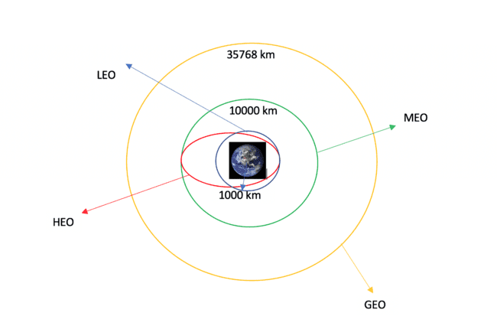

Figure : Orbit Information

### **TASK 2: Calculate the number and occurrence of each orbit**

Use the method .**value_counts()** to determine the number and occurrence of each orbit in the column **Orbit**

In [6]:

*# Apply value_counts on Orbit column*

df['Orbit']**.**value_counts()

Out[6]:

GTO 27

ISS 21

VLEO 14

PO 9

LEO 7

SSO 5

MEO 3

ES-L1 1

HEO 1

SO 1

GEO 1

Name: Orbit, dtype: int64

### **TASK 3: Calculate the number and occurrence of mission outcome per orbit type**

Use the method .**value_counts()**on the column **Outcome** to determine the number of **landing_outcomes**.Then assign it to a variable landing_outcomes.

In [8]:

*# landing_outcomes = values on Outcome column*

landing_outcomes **=** df['Outcome']**.**value_counts()

landing_outcomes

Out[8]:

True ASDS 41

None None 19

True RTLS 14

False ASDS 6

True Ocean 5

False Ocean 2

None ASDS 2

False RTLS 1

Name: Outcome, dtype: int64

True Ocean means the mission outcome was successfully landed to a specific region of the ocean while False Ocean means the mission outcome was unsuccessfully landed to a specific region of the ocean. True RTLS means the mission outcome was successfully landed to a ground pad False RTLS means the mission outcome was unsuccessfully landed to a ground pad. True ASDS means the mission outcome was successfully landed to a drone ship False ASDS means the mission outcome was unsuccessfully landed to a drone ship. None ASDS and None these represent a failure to land.

In [9]:

**for** i,outcome **in** enumerate(landing_outcomes**.**keys()):

print(i,outcome)

0 True ASDS

1 None None

2 True RTLS

3 False ASDS

4 True Ocean

5 False Ocean

6 None ASDS

7 False RTLS

We create a set of outcomes where the second stage did not land successfully:

In [10]:

bad_outcomes**=**set(landing_outcomes**.**keys()[[1,3,5,6,7]])

bad_outcomes

Out[10]:

{'False ASDS', 'False Ocean', 'False RTLS', 'None ASDS', 'None None'}

### **TASK 4: Create a landing outcome label from Outcome column**

Using the Outcome, create a list where the element is zero if the corresponding row in Outcome is in the set bad_outcome; otherwise, it's one. Then assign it to the variable landing_class:

In [11]:

*# landing_class = 0 if bad_outcome*

*# landing_class = 1 otherwise*

landing_class **=** []

**for** row **in** df['Outcome']:

**if** row **in** bad_outcomes:

landing_class**.**append(0)

**else**:

landing_class**.**append(1)

This variable will represent the classification variable that represents the outcome of each launch. If the value is zero, the first stage did not land successfully; one means the first stage landed Successfully

In [12]:

df['Class']**=**landing_class

df[['Class']]**.**head(8)

Out[12]:

|  | **Class** |
| --- | --- |
| **0** | 0 |
| **1** | 0 |
| **2** | 0 |
| **3** | 0 |
| **4** | 0 |
| **5** | 0 |
| **6** | 1 |
| **7** | 1 |

In [13]:

df**.**head(5)

df["Class"]**.**mean()

Out[14]:

0.6666666666666666

We can now export it to a CSV for the next section, but to make the answers consistent, in the next lab we will provide data in a pre-selected date range.

In [15]:

df**.**to_csv("dataset_part\_2.csv", index**=False**)

df.to_csv("dataset_part\_2.csv", index=False)

## Authors

[Joseph Santarcangelo](https://www.linkedin.com/in/joseph-s-50398b136/?utm_medium=Exinfluencer&utm_source=Exinfluencer&utm_content=000026UJ&utm_term=10006555&utm_id=NA-SkillsNetwork-Channel-SkillsNetworkCoursesIBMDS0321ENSkillsNetwork26802033-2021-01-01) has a PhD in Electrical Engineering, his research focused on using machine learning, signal processing, and computer vision to determine how videos impact human cognition. Joseph has been working for IBM since he completed his PhD.

[Nayef Abou Tayoun](https://www.linkedin.com/in/nayefaboutayoun/?utm_medium=Exinfluencer&utm_source=Exinfluencer&utm_content=000026UJ&utm_term=10006555&utm_id=NA-SkillsNetwork-Channel-SkillsNetworkCoursesIBMDS0321ENSkillsNetwork26802033-2021-01-01) is a Data Scientist at IBM and pursuing a Master of Management in Artificial intelligence degree at Queen's University.

## Change Log

Table : Week 1.3 Change log

| **Date (YYYY-MM-DD)** | **Version** | **Changed By** | **Change Description** |
| --- | --- | --- | --- |
| 2021-08-31 | 1.1 | Lakshmi Holla | Changed Markdown |
| 2020-09-20 | 1.0 | Joseph | Modified Multiple Areas |
| 2020-11-04 | 1.1. | Nayef | updating the input data |
| 2021-05-026 | 1.1. | Joseph | updating the input data |

## 2️⃣ Chapter 2: Exploratory Data Analysis (EDA)

**2.1: [Exploratory Analysis Using SQL](https://github.com/sachinrathi1997/SpaceX_DS_Project/blob/main/jupyter-labs-eda-sql-coursera.ipynb)**

# Assignment: SQL Notebook for Peer Assignment

Estimated time needed: **60** minutes.

## Introduction

Using this Python notebook, you will:

1. Understand the Spacex DataSet
2. Load the dataset into the corresponding table in a Db2 database
3. Execute SQL queries to answer assignment questions

## Overview of the Dataset

SpaceX has gained worldwide attention for a series of historic milestones.

It is the only private company ever to return a spacecraft from low-earth orbit, which it first accomplished in December 2010. SpaceX advertises Falcon 9 rocket launches on its website with a cost of 62 million dollars whereas other providers cost upward of 165 million dollars each, much of the savings is because Space X can reuse the first stage.

Therefore, if we can determine if the first stage will land, we can determine the cost of a launch.

This information can be used if an alternate company wants to bid against SpaceX for a rocket launch.

This dataset includes a record for each payload carried during a SpaceX mission into outer space.

### Download the datasets

This assignment requires you to load the spacex dataset.

In many cases the dataset to be analyzed is available as a .CSV (comma separated values) file, perhaps on the internet. Click on the link below to download and save the dataset (.CSV file):

[SpaceX Dataset](https://cf-courses-data.s3.us.cloud-object-storage.appdomain.cloud/IBM-DS0321EN-SkillsNetwork/labs/module_2/data/Spacex.csv?utm_medium=Exinfluencer&utm_source=Exinfluencer&utm_content=000026UJ&utm_term=10006555&utm_id=NA-SkillsNetwork-Channel-SkillsNetworkCoursesIBMDS0321ENSkillsNetwork26802033-2021-01-01)

### Store the dataset in database table

**it is highly recommended to manually load the table using the database console LOAD tool in DB2**.

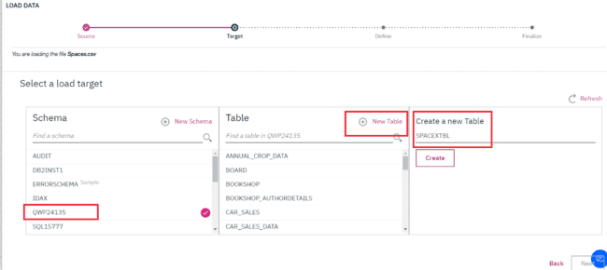

Figure : Load Data in New Table

Now open the Db2 console, open the LOAD tool, Select / Drag the .CSV file for the dataset, Next create a New Table, and then follow the steps on-screen instructions to load the data. Name the new table as follows:

**SPACEX DATASET**

**Follow these steps while using old DB2 UI which is having Open Console Screen**

**Note:While loading Spacex dataset, ensure that detect datatypes is disabled. Later click on the pencil icon(edit option).**

1. Change the Date Format by manually typing DD-MM-YYYY and timestamp format as DD-MM-YYYY HH\:MM:SS.

Here you should place the cursor at Date field and manually type as DD-MM-YYYY.

1. Change the PAYLOADMASS\_KG_ datatype to INTEGER.

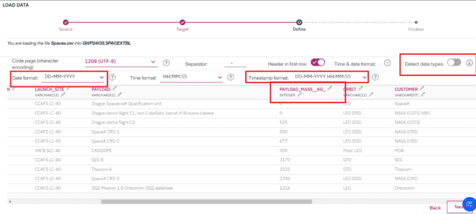

Figure : SpaceX.csv

**Changes to be considered when having DB2 instance with the new UI having Go to UI screen**

* Refer to this insruction in this [link](https://cf-courses-data.s3.us.cloud-object-storage.appdomain.cloud/IBMDeveloperSkillsNetwork-DB0201EN-SkillsNetwork/labs/Labs_Coursera_V5/labs/Lab%20-%20Sign%20up%20for%20IBM%20Cloud%20-%20Create%20Db2%20service%20instance%20-%20Get%20started%20with%20the%20Db2%20console/instructional-labs.md.html?utm_medium=Exinfluencer&utm_source=Exinfluencer&utm_content=000026UJ&utm_term=10006555&utm_id=NA-SkillsNetwork-Channel-SkillsNetworkCoursesIBMDS0321ENSkillsNetwork26802033-2021-01-01) for viewing the new Go to UI screen.
* Later click on **Data link(below SQL)** in the Go to UI screen and click on **Load Data** tab.
* Later browse for the downloaded spacex file.

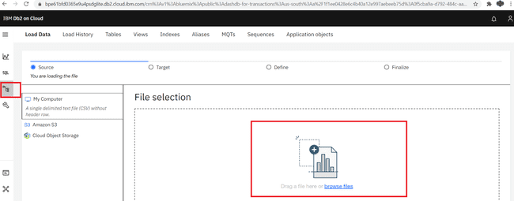

Figure : File Selection and Load the file

* Once done select the schema and load the file.

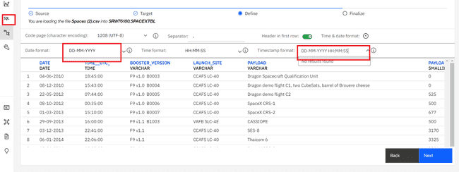

Figure : SpaceX(2).csv

In [1]:

**!**pip install sqlalchemy**==**1.3.9

**!**pip install ibm_db_sa

**!**pip install ipython-sql

Collecting sqlalchemy==1.3.9

Downloading SQLAlchemy-1.3.9.tar.gz (6.0 MB)

━━━━━━━━━━━━━━━━━━━━━━━━━━━━━━━━━━━━━━━━ 6.0/6.0 MB 53.7 MB/s eta 0:00:00:00:0100:01

Preparing metadata (setup.py) ... done

Building wheels for collected packages: sqlalchemy

Building wheel for sqlalchemy (setup.py) ... done

Created wheel for sqlalchemy: filename=SQLAlchemy-1.3.9-cp37-cp37m-linux_x86_64.whl size=1159140 sha256=42289e41625766e73004e9f6a3e00ebddc3f73b4c8ff7ccfd7ae7eb8f922c5fc

Stored in directory: /home/jupyterlab/.cache/pip/wheels/03/71/13/010faf12246f72dc76b4150e6e599d13a85b4435e06fb9e51f

Successfully built sqlalchemy

Installing collected packages: sqlalchemy

Attempting uninstall: sqlalchemy

Found existing installation: SQLAlchemy 1.3.24

Uninstalling SQLAlchemy-1.3.24:

Successfully uninstalled SQLAlchemy-1.3.24

Successfully installed sqlalchemy-1.3.9

Requirement already satisfied: ibm_db_sa in /home/jupyterlab/conda/envs/python/lib/python3.7/site-packages (0.3.3)

Requirement already satisfied: sqlalchemy>=0.7.3 in /home/jupyterlab/conda/envs/python/lib/python3.7/site-packages (from ibm_db_sa) (1.3.9)

Requirement already satisfied: ipython-sql in /home/jupyterlab/conda/envs/python/lib/python3.7/site-packages (0.3.9)

Requirement already satisfied: ipython>=1.0 in /home/jupyterlab/conda/envs/python/lib/python3.7/site-packages (from ipython-sql) (7.32.0)

Requirement already satisfied: ipython-genutils>=0.1.0 in /home/jupyterlab/conda/envs/python/lib/python3.7/site-packages (from ipython-sql) (0.2.0)

Requirement already satisfied: prettytable in /home/jupyterlab/conda/envs/python/lib/python3.7/site-packages (from ipython-sql) (3.2.0)

Requirement already satisfied: six in /home/jupyterlab/conda/envs/python/lib/python3.7/site-packages (from ipython-sql) (1.16.0)

Requirement already satisfied: sqlalchemy>=0.6.7 in /home/jupyterlab/conda/envs/python/lib/python3.7/site-packages (from ipython-sql) (1.3.9)

Requirement already satisfied: sqlparse in /home/jupyterlab/conda/envs/python/lib/python3.7/site-packages (from ipython-sql) (0.4.2)

Requirement already satisfied: jedi>=0.16 in /home/jupyterlab/conda/envs/python/lib/python3.7/site-packages (from ipython>=1.0->ipython-sql) (0.18.1)

Requirement already satisfied: prompt-toolkit!=3.0.0,!=3.0.1,<3.1.0,>=2.0.0 in /home/jupyterlab/conda/envs/python/lib/python3.7/site-packages (from ipython>=1.0->ipython-sql) (3.0.29)

Requirement already satisfied: pexpect>4.3 in /home/jupyterlab/conda/envs/python/lib/python3.7/site-packages (from ipython>=1.0->ipython-sql) (4.8.0)

Requirement already satisfied: pickleshare in /home/jupyterlab/conda/envs/python/lib/python3.7/site-packages (from ipython>=1.0->ipython-sql) (0.7.5)

Requirement already satisfied: traitlets>=4.2 in /home/jupyterlab/conda/envs/python/lib/python3.7/site-packages (from ipython>=1.0->ipython-sql) (5.1.1)

Requirement already satisfied: backcall in /home/jupyterlab/conda/envs/python/lib/python3.7/site-packages (from ipython>=1.0->ipython-sql) (0.2.0)

Requirement already satisfied: decorator in /home/jupyterlab/conda/envs/python/lib/python3.7/site-packages (from ipython>=1.0->ipython-sql) (5.1.1)

Requirement already satisfied: pygments in /home/jupyterlab/conda/envs/python/lib/python3.7/site-packages (from ipython>=1.0->ipython-sql) (2.11.2)

Requirement already satisfied: setuptools>=18.5 in /home/jupyterlab/conda/envs/python/lib/python3.7/site-packages (from ipython>=1.0->ipython-sql) (62.1.0)

Requirement already satisfied: matplotlib-inline in /home/jupyterlab/conda/envs/python/lib/python3.7/site-packages (from ipython>=1.0->ipython-sql) (0.1.3)

Requirement already satisfied: wcwidth in /home/jupyterlab/conda/envs/python/lib/python3.7/site-packages (from prettytable->ipython-sql) (0.2.5)

Requirement already satisfied: importlib-metadata in /home/jupyterlab/conda/envs/python/lib/python3.7/site-packages (from prettytable->ipython-sql) (4.11.3)

Requirement already satisfied: parso<0.9.0,>=0.8.0 in /home/jupyterlab/conda/envs/python/lib/python3.7/site-packages (from jedi>=0.16->ipython>=1.0->ipython-sql) (0.8.3)

Requirement already satisfied: ptyprocess>=0.5 in /home/jupyterlab/conda/envs/python/lib/python3.7/site-packages (from pexpect>4.3->ipython>=1.0->ipython-sql) (0.7.0)

Requirement already satisfied: typing-extensions>=3.6.4 in /home/jupyterlab/conda/envs/python/lib/python3.7/site-packages (from importlib-metadata->prettytable->ipython-sql) (4.2.0)

Requirement already satisfied: zipp>=0.5 in /home/jupyterlab/conda/envs/python/lib/python3.7/site-packages (from importlib-metadata->prettytable->ipython-sql) (3.8.0)

### Connect to the database

Let us first load the SQL extension and establish a connection with the database

In [2]:

**%load_ext** sql

**DB2 magic in case of old UI service credentials.**

In the next cell enter your db2 connection string. Recall you created Service Credentials for your Db2 instance before. From the **uri** field of your Db2 service credentials copy everything after db2:// (except the double quote at the end) and paste it in the cell below after ibm_db_sa://

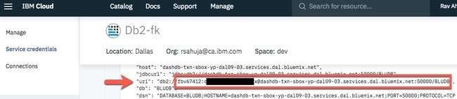

Figure : Db2-fk

in the following format

**%sql ibm_db_sa://my-username:my-password\@my-hostname:my-port/my-db-name**

**DB2 magic in case of new UI service credentials.**

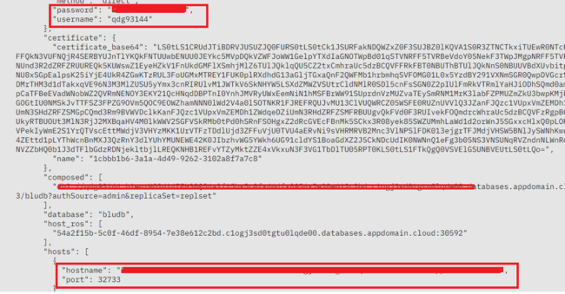

Figure : %sql ibm_db_sa://my-username:my-password\@my-hostname:my-port/my-db-name

* Use the following format.
* Add security=SSL at the end

**%sql ibm_db_sa://my-username:my-password\@my-hostname:my-port/my-db-name?security=SSL**

In [6]:

**%sql** ibm_db_sa://glq09342:qwptGfJNs4DgeVNk@1bbf73c5-d84a-4bb0-85b9-ab1a4348f4a4.c3n41cmd0nqnrk39u98g.databases.appdomain.cloud:32286/BLUDB?security=SSL

Out[6]:

'Connected: glq09342@BLUDB'

In [8]:

**%sql** select * from spacex

* ibm_db_sa://glq09342:***@1bbf73c5-d84a-4bb0-85b9-ab1a4348f4a4.c3n41cmd0nqnrk39u98g.databases.appdomain.cloud:32286/BLUDB

Done.

Out[8]:

Table : Dataset

| **DATE** | **time__utc_** | **booster_version** | **launch_site** | **payload** | **payload_mass__kg_** | **orbit** | **customer** | **mission_outcome** | **landing__outcome** |
| --- | --- | --- | --- | --- | --- | --- | --- | --- | --- |
| 2010-06-04 | 18:45:00 | F9 v1.0 B0003 | CCAFS LC-40 | Dragon Spacecraft Qualification Unit | 0 | LEO | SpaceX | Success | Failure (parachute) |
| 2010-12-08 | 15:43:00 | F9 v1.0 B0004 | CCAFS LC-40 | Dragon demo flight C1, two CubeSats, barrel of Brouere cheese | 0 | LEO (ISS) | NASA (COTS) NRO | Success | Failure (parachute) |
| 2012-05-22 | 07:44:00 | F9 v1.0 B0005 | CCAFS LC-40 | Dragon demo flight C2 | 525 | LEO (ISS) | NASA (COTS) | Success | No attempt |
| 2012-10-08 | 00:35:00 | F9 v1.0 B0006 | CCAFS LC-40 | SpaceX CRS-1 | 500 | LEO (ISS) | NASA (CRS) | Success | No attempt |
| 2013-03-01 | 15:10:00 | F9 v1.0 B0007 | CCAFS LC-40 | SpaceX CRS-2 | 677 | LEO (ISS) | NASA (CRS) | Success | No attempt |
| 2013-09-29 | 16:00:00 | F9 v1.1 B1003 | VAFB SLC-4E | CASSIOPE | 500 | Polar LEO | MDA | Success | Uncontrolled (ocean) |
| 2013-12-03 | 22:41:00 | F9 v1.1 | CCAFS LC-40 | SES-8 | 3170 | GTO | SES | Success | No attempt |
| 2014-01-06 | 22:06:00 | F9 v1.1 | CCAFS LC-40 | Thaicom 6 | 3325 | GTO | Thaicom | Success | No attempt |
| 2014-04-18 | 19:25:00 | F9 v1.1 | CCAFS LC-40 | SpaceX CRS-3 | 2296 | LEO (ISS) | NASA (CRS) | Success | Controlled (ocean) |
| 2014-07-14 | 15:15:00 | F9 v1.1 | CCAFS LC-40 | OG2 Mission 1 6 Orbcomm-OG2 satellites | 1316 | LEO | Orbcomm | Success | Controlled (ocean) |
| 2014-08-05 | 08:00:00 | F9 v1.1 | CCAFS LC-40 | AsiaSat 8 | 4535 | GTO | AsiaSat | Success | No attempt |
| 2014-09-07 | 05:00:00 | F9 v1.1 B1011 | CCAFS LC-40 | AsiaSat 6 | 4428 | GTO | AsiaSat | Success | No attempt |
| 2014-09-21 | 05:52:00 | F9 v1.1 B1010 | CCAFS LC-40 | SpaceX CRS-4 | 2216 | LEO (ISS) | NASA (CRS) | Success | Uncontrolled (ocean) |
| 2015-01-10 | 09:47:00 | F9 v1.1 B1012 | CCAFS LC-40 | SpaceX CRS-5 | 2395 | LEO (ISS) | NASA (CRS) | Success | Failure (drone ship) |
| 2015-02-11 | 23:03:00 | F9 v1.1 B1013 | CCAFS LC-40 | DSCOVR | 570 | HEO | U.S. Air Force NASA NOAA | Success | Controlled (ocean) |
| 2015-03-02 | 03:50:00 | F9 v1.1 B1014 | CCAFS LC-40 | ABS-3A Eutelsat 115 West B | 4159 | GTO | ABS Eutelsat | Success | No attempt |
| 2015-04-14 | 20:10:00 | F9 v1.1 B1015 | CCAFS LC-40 | SpaceX CRS-6 | 1898 | LEO (ISS) | NASA (CRS) | Success | Failure (drone ship) |
| 2015-04-27 | 23:03:00 | F9 v1.1 B1016 | CCAFS LC-40 | Turkmen 52 / MonacoSAT | 4707 | GTO | Turkmenistan National Space Agency | Success | No attempt |
| 2015-06-28 | 14:21:00 | F9 v1.1 B1018 | CCAFS LC-40 | SpaceX CRS-7 | 1952 | LEO (ISS) | NASA (CRS) | Failure (in flight) | Precluded (drone ship) |
| 2015-12-22 | 01:29:00 | F9 FT B1019 | CCAFS LC-40 | OG2 Mission 2 11 Orbcomm-OG2 satellites | 2034 | LEO | Orbcomm | Success | Success (ground pad) |
| 2016-01-17 | 18:42:00 | F9 v1.1 B1017 | VAFB SLC-4E | Jason-3 | 553 | LEO | NASA (LSP) NOAA CNES | Success | Failure (drone ship) |
| 2016-03-04 | 23:35:00 | F9 FT B1020 | CCAFS LC-40 | SES-9 | 5271 | GTO | SES | Success | Failure (drone ship) |
| 2016-04-08 | 20:43:00 | F9 FT B1021.1 | CCAFS LC-40 | SpaceX CRS-8 | 3136 | LEO (ISS) | NASA (CRS) | Success | Success (drone ship) |
| 2016-05-06 | 05:21:00 | F9 FT B1022 | CCAFS LC-40 | JCSAT-14 | 4696 | GTO | SKY Perfect JSAT Group | Success | Success (drone ship) |
| 2016-05-27 | 21:39:00 | F9 FT B1023.1 | CCAFS LC-40 | Thaicom 8 | 3100 | GTO | Thaicom | Success | Success (drone ship) |
| 2016-06-15 | 14:29:00 | F9 FT B1024 | CCAFS LC-40 | ABS-2A Eutelsat 117 West B | 3600 | GTO | ABS Eutelsat | Success | Failure (drone ship) |
| 2016-07-18 | 04:45:00 | F9 FT B1025.1 | CCAFS LC-40 | SpaceX CRS-9 | 2257 | LEO (ISS) | NASA (CRS) | Success | Success (ground pad) |
| 2016-08-14 | 05:26:00 | F9 FT B1026 | CCAFS LC-40 | JCSAT-16 | 4600 | GTO | SKY Perfect JSAT Group | Success | Success (drone ship) |
| 2017-01-14 | 17:54:00 | F9 FT B1029.1 | VAFB SLC-4E | Iridium NEXT 1 | 9600 | Polar LEO | Iridium Communications | Success | Success (drone ship) |
| 2017-02-19 | 14:39:00 | F9 FT B1031.1 | KSC LC-39A | SpaceX CRS-10 | 2490 | LEO (ISS) | NASA (CRS) | Success | Success (ground pad) |
| 2017-03-16 | 06:00:00 | F9 FT B1030 | KSC LC-39A | EchoStar 23 | 5600 | GTO | EchoStar | Success | No attempt |
| 2017-03-30 | 22:27:00 | F9 FT B1021.2 | KSC LC-39A | SES-10 | 5300 | GTO | SES | Success | Success (drone ship) |
| 2017-05-01 | 11:15:00 | F9 FT B1032.1 | KSC LC-39A | NROL-76 | 5300 | LEO | NRO | Success | Success (ground pad) |
| 2017-05-15 | 23:21:00 | F9 FT B1034 | KSC LC-39A | Inmarsat-5 F4 | 6070 | GTO | Inmarsat | Success | No attempt |
| 2017-06-03 | 21:07:00 | F9 FT B1035.1 | KSC LC-39A | SpaceX CRS-11 | 2708 | LEO (ISS) | NASA (CRS) | Success | Success (ground pad) |
| 2017-06-23 | 19:10:00 | F9 FT B1029.2 | KSC LC-39A | BulgariaSat-1 | 3669 | GTO | Bulsatcom | Success | Success (drone ship) |

## Tasks

Now write and execute SQL queries to solve the assignment tasks.

### **Task 1**

##### Display the names of the unique launch sites in the space mission

In [9]:

**%sql** select distinct launch_site from spacex

* ibm_db_sa://glq09342:***@1bbf73c5-d84a-4bb0-85b9-ab1a4348f4a4.c3n41cmd0nqnrk39u98g.databases.appdomain.cloud:32286/BLUDB

Done.

Out[9]:

Table : Launch_site

| **launch_site** |
| --- |
| CCAFS LC-40 |
| CCAFS SLC-40 |
| KSC LC-39A |
| VAFB SLC-4E |

### **Task 2**

##### Display 5 records where launch sites begin with the string 'CCA'

In [18]:

**%sql** select * from Spacex where launch_site like 'CCA%' limit 5

* ibm_db_sa://glq09342:***@1bbf73c5-d84a-4bb0-85b9-ab1a4348f4a4.c3n41cmd0nqnrk39u98g.databases.appdomain.cloud:32286/BLUDB

Done.

Out[18]:

Table : Display 5 records where launch sites begin with the string 'CCA'

| **DATE** | **time__utc_** | **booster_version** | **launch_site** | **payload** | **payload_mass__kg_** | **orbit** | **customer** | **mission_outcome** | **landing__outcome** |
| --- | --- | --- | --- | --- | --- | --- | --- | --- | --- |
| 2010-06-04 | 18:45:00 | F9 v1.0 B0003 | CCAFS LC-40 | Dragon Spacecraft Qualification Unit | 0 | LEO | SpaceX | Success | Failure (parachute) |
| 2010-12-08 | 15:43:00 | F9 v1.0 B0004 | CCAFS LC-40 | Dragon demo flight C1, two CubeSats, barrel of Brouere cheese | 0 | LEO (ISS) | NASA (COTS) NRO | Success | Failure (parachute) |
| 2012-05-22 | 07:44:00 | F9 v1.0 B0005 | CCAFS LC-40 | Dragon demo flight C2 | 525 | LEO (ISS) | NASA (COTS) | Success | No attempt |
| 2012-10-08 | 00:35:00 | F9 v1.0 B0006 | CCAFS LC-40 | SpaceX CRS-1 | 500 | LEO (ISS) | NASA (CRS) | Success | No attempt |
| 2013-03-01 | 15:10:00 | F9 v1.0 B0007 | CCAFS LC-40 | SpaceX CRS-2 | 677 | LEO (ISS) | NASA (CRS) | Success | No attempt |

### **Task 3**

##### Display the total payload mass carried by boosters launched by NASA (CRS)

In [19]:

**%sql** select sum(payload_mass__kg_) from spacex where customer like 'NASA%'

* ibm_db_sa://glq09342:***@1bbf73c5-d84a-4bb0-85b9-ab1a4348f4a4.c3n41cmd0nqnrk39u98g.databases.appdomain.cloud:32286/BLUDB

Done.

Out[19]:

Table : Display the total payload mass carried by boosters launched by NASA (CRS)

| **1** |
| --- |
| 99980 |

### **Task 4**

##### Display average payload mass carried by booster version F9 v1.1

In [20]:

**%sql** select AVG(payload_mass__kg_) from spacex where booster_version like 'F9 v1.1%'

* ibm_db_sa://glq09342:***@1bbf73c5-d84a-4bb0-85b9-ab1a4348f4a4.c3n41cmd0nqnrk39u98g.databases.appdomain.cloud:32286/BLUDB

Done.

Out[20]:

Table : Display average payload mass carried by booster version F9 v1.1

| **1** |
| --- |
| 2534 |

### **Task 5**

##### List the date when the first successful landing outcome in ground pad was achieved.

Hint: Use min function

In [21]:

**%sql** select MIN(DATE) from spacex where landing__outcome like '%ground pad%'

* ibm_db_sa://glq09342:***@1bbf73c5-d84a-4bb0-85b9-ab1a4348f4a4.c3n41cmd0nqnrk39u98g.databases.appdomain.cloud:32286/BLUDB

Done.

Out[21]:

Table : List the date when the first successful landing outcome in ground pad was achieved.

| **1** |
| --- |
| 2015-12-22 |

### **Task 6**

##### List the names of the boosters which have success in drone ship and have payload mass greater than 4000 but less than 6000

In [22]:

**%sql** select distinct booster_version from spacex where (payload_mass__kg_ < 6000 AND payload_mass__kg_ > 4000) AND (landing__outcome like '%drone%ship%')

* ibm_db_sa://glq09342:***@1bbf73c5-d84a-4bb0-85b9-ab1a4348f4a4.c3n41cmd0nqnrk39u98g.databases.appdomain.cloud:32286/BLUDB

Done.

Out[22]:

Table : List the names of the boosters which have success in drone ship and have payload mass greater than 4000 but less than 6000

| **booster_version** |
| --- |
| F9 FT B1021.2 |
| F9 FT B1031.2 |
| F9 FT B1020 |
| F9 FT B1022 |
| F9 FT B1026 |

### **Task 7**

##### List the total number of successful and failure mission outcomes

In [23]:

**%sql** SELECT mission_outcome, count(*) AS total FROM spacex GROUP BY mission_outcome

* ibm_db_sa://glq09342:***@1bbf73c5-d84a-4bb0-85b9-ab1a4348f4a4.c3n41cmd0nqnrk39u98g.databases.appdomain.cloud:32286/BLUDB

Done.

Out[23]:

Table : List the total number of successful and failure mission outcomes

| **mission_outcome** | **total** |
| --- | --- |
| Failure (in flight) | 1 |
| Success | 99 |
| Success (payload status unclear) | 1 |

### **Task 8**

##### List the names of the booster versions which have carried the maximum payload mass. Use a subquery

In [24]:

**%sql** SELECT DISTINCT (booster_version) from spacex where payload_mass__kg_ = (SELECT MAX(payload_mass__kg_) from spacex)

* ibm_db_sa://glq09342:***@1bbf73c5-d84a-4bb0-85b9-ab1a4348f4a4.c3n41cmd0

qnrk39u98g.databases.appdomain.cloud:32286/BLUDB

Done.

Out[24]:

Table : List the names of the booster versions which have carried the maximum payload mass. Use a subquery

| **booster_version** |
| --- |
| F9 B5 B1048.4 |
| F9 B5 B1048.5 |
| F9 B5 B1049.4 |
| F9 B5 B1049.5 |
| F9 B5 B1049.7 |
| F9 B5 B1051.3 |
| F9 B5 B1051.4 |
| F9 B5 B1051.6 |
| F9 B5 B1056.4 |
| F9 B5 B1058.3 |
| F9 B5 B1060.2 |
| F9 B5 B1060.3 |

### **Task 9**

##### List the failed landing_outcomes in drone ship, their booster versions, and launch site names for in year 2015

In [25]:

**%sql** select booster_version, launch_site from spacex where landing__outcome = 'Failure (drone ship)' AND DATE like '2015%'

* ibm_db_sa://glq09342:***@1bbf73c5-d84a-4bb0-85b9-ab1a4348f4a4.c3n41cmd0nqnrk39u98g.databases.appdomain.cloud:32286/BLUDB

Done.

Out[25]:

Table : List the failed landing_outcomes in drone ship, their booster versions, and launch site names for in year 2015

| **booster_version** | **launch_site** |
| --- | --- |
| F9 v1.1 B1012 | CCAFS LC-40 |
| F9 v1.1 B1015 | CCAFS LC-40 |

### **Task 10**

##### Rank the count of landing outcomes (such as Failure (drone ship) or Success (ground pad)) between the date 2010-06-04 and 2017-03-20, in descending order

In [26]:

**%sql** SELECT * FROM spacex where DAYNAME(DATE)='Friday' LIMIT 5

* ibm_db_sa://glq09342:***@1bbf73c5-d84a-4bb0-85b9-ab1a4348f4a4.c3n41cmd0nqnrk39u98g.databases.appdomain.cloud:32286/BLUDB

Done.

Out[26]:

Table : Rank the count of landing outcomes (such as Failure (drone ship) or Success (ground pad)) between the date 2010-06-04 and 2017-03-20, in descending order

| **DATE** | **time__utc_** | **booster_version** | **launch_site** | **payload** | **payload_mass__kg_** | **orbit** | **customer** | **mission_outcome** | **landing__outcome** |
| --- | --- | --- | --- | --- | --- | --- | --- | --- | --- |
| 2010-06-04 | 18:45:00 | F9 v1.0 B0003 | CCAFS LC-40 | Dragon Spacecraft Qualification Unit | 0 | LEO | SpaceX | Success | Failure (parachute) |
| 2013-03-01 | 15:10:00 | F9 v1.0 B0007 | CCAFS LC-40 | SpaceX CRS-2 | 677 | LEO (ISS) | NASA (CRS) | Success | No attempt |
| 2014-04-18 | 19:25:00 | F9 v1.1 | CCAFS LC-40 | SpaceX CRS-3 | 2296 | LEO (ISS) | NASA (CRS) | Success | Controlled (ocean) |
| 2016-03-04 | 23:35:00 | F9 FT B1020 | CCAFS LC-40 | SES-9 | 5271 | GTO | SES | Success | Failure (drone ship) |
| 2016-04-08 | 20:43:00 | F9 FT B1021.1 | CCAFS LC-40 | SpaceX CRS-8 | 3136 | LEO (ISS) | NASA (CRS) | Success | Success (drone ship) |

## Author(s)

#### Lakshmi Holla

## Other Contributors

#### Rav Ahuja

## Change log

Table : Week 2.1 Change Log

| **Date** | **Version** | **Changed by** | **Change Description** |
| --- | --- | --- | --- |
| 2021-10-12 | 0.4 | Lakshmi Holla | Changed markdown |
| 2021-08-24 | 0.3 | Lakshmi Holla | Added library update |
| 2021-07-09 | 0.2 | Lakshmi Holla | Changes made in magic sql |

**2.2: [Exploratory Analysis Using Pandas and Matplotlib](https://github.com/sachinrathi1997/SpaceX_DS_Project/blob/main/jupyter-labs-eda-dataviz.ipynb)**

# ****SpaceX Falcon 9 First Stage Landing Prediction****

## Assignment: Exploring and Preparing Data

Estimated time needed: **70** minutes

In this assignment, we will predict if the Falcon 9 first stage will land successfully. SpaceX advertises Falcon 9 rocket launches on its website with a cost of 62 million dollars; other providers cost upward of 165 million dollars each, much of the savings is because SpaceX can reuse the first stage.

In this lab, you will perform Exploratory Data Analysis and Feature Engineering.

Falcon 9 first stage will land successfully

Several examples of an unsuccessful landing are shown here:

Most unsuccessful landings are planned. Space X performs a controlled landing in the oceans.

## Objectives

Perform exploratory Data Analysis and Feature Engineering using **Pandas** and **Matplotlib**

* Exploratory Data Analysis
* Preparing Data Feature Engineering

### **Import Libraries and Define Auxiliary Functions**

We will import the following libraries the lab

In [6]:

*# andas is a software library written for the Python programming language for data manipulation and analysis.*

**import** pandas **as** pd

*#NumPy is a library for the Python programming language, adding support for large, multi-dimensional arrays and matrices, along with a large collection of high-level mathematical functions to operate on these arrays*

**import** numpy **as** np

*# Matplotlib is a plotting library for python and pyplot gives us a MatLab like plotting framework. We will use this in our plotter function to plot data.*

**import** matplotlib.pyplot **as** plt

*#Seaborn is a Python data visualization library based on matplotlib. It provides a high-level interface for drawing attractive and informative statistical graphics*

**import** seaborn **as** sns

## Exploratory Data Analysis

First, let's read the SpaceX dataset into a Pandas dataframe and print its summary

In [7]:

df**=**pd**.**read_csv("https://cf-courses-data.s3.us.cloud-object-storage.appdomain.cloud/IBM-DS0321EN-SkillsNetwork/datasets/dataset_part_2.csv")

*# If you were unable to complete the previous lab correctly you can uncomment and load this csv*

*# df = pd.read_csv('https://cf-courses-data.s3.us.cloud-object-storage.appdomain.cloud/IBMDeveloperSkillsNetwork-DS0701EN-SkillsNetwork/api/dataset_part_2.csv')*

df**.**head(5)

Out[7]:

Table : SpaceX dataset into a Pandas dataframe and its summary

|  | **FlightNumber** | **Date** | **BoosterVersion** | **PayloadMass** | **Orbit** | **LaunchSite** | **Outcome** | **Flights** | **GridFins** | **Reused** | **Legs** | **LandingPad** | **Block** | **ReusedCount** | **Serial** | **Longitude** | **Latitude** | **Class** |
| --- | --- | --- | --- | --- | --- | --- | --- | --- | --- | --- | --- | --- | --- | --- | --- | --- | --- | --- |
| **0** | 1 | 2010-06-04 | Falcon 9 | 6104.959412 | LEO | CCAFS SLC 40 | None None | 1 | False | False | False | NaN | 1.0 | 0 | B0003 | -80.577366 | 28.561857 | 0 |
| **1** | 2 | 2012-05-22 | Falcon 9 | 525.000000 | LEO | CCAFS SLC 40 | None None | 1 | False | False | False | NaN | 1.0 | 0 | B0005 | -80.577366 | 28.561857 | 0 |
| **2** | 3 | 2013-03-01 | Falcon 9 | 677.000000 | ISS | CCAFS SLC 40 | None None | 1 | False | False | False | NaN | 1.0 | 0 | B0007 | -80.577366 | 28.561857 | 0 |
| **3** | 4 | 2013-09-29 | Falcon 9 | 500.000000 | PO | VAFB SLC 4E | False Ocean | 1 | False | False | False | NaN | 1.0 | 0 | B1003 | -120.610829 | 34.632093 | 0 |
| **4** | 5 | 2013-12-03 | Falcon 9 | 3170.000000 | GTO | CCAFS SLC 40 | None None | 1 | False | False | False | NaN | 1.0 | 0 | B1004 | -80.577366 | 28.561857 | 0 |

First, let's try to see how the **FlightNumber** (indicating the continuous launch attempts.) and **Payload**variables would affect the launch outcome.

We can plot out the **FlightNumber** vs.**PayloadMassand** overlay the outcome of the launch. We see that as the flight number increases, the first stage is more likely to land successfully. The payload mass is also important; it seems the more massive the payload, the less likely the first stage will return.

In [8]:

sns**.**catplot(y**=**"PayloadMass", x**=**"FlightNumber", hue**=**"Class", data**=**df, aspect **=** 5)

plt**.**xlabel("Flight Number",fontsize**=**20)

plt**.**ylabel("Pay load Mass (kg)",fontsize**=**20)

plt**.**show()

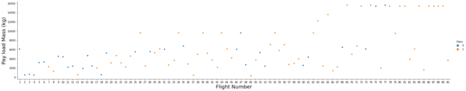

Figure : FlightNumber vs. PayloadMassand

We see that different launch sites have different success rates. **CCAFS LC-40,** has a success rate of 60 %, while **KSC LC-39A**and **VAFB SLC 4E** has a success rate of 77%.

Next, let's drill down to each site visualize its detailed launch records.

### **TASK 1: Visualize the relationship between Flight Number and Launch Site**

Use the function **catplot** to plot **FlightNumber** vs **LaunchSite**, set the parameter **x** parameter to **FlightNumber**, set the **y** to **Launch** Site and set the parameter **hue** to '**class**'

Now try to explain the patterns you found in the Flight Number vs. Launch Site scatter point plots.

In [10]:

*# Plot a scatter point chart with x axis to be Flight Number and y axis to be the launch site, and hue to be the class value*

sns**.**catplot(x**=**"FlightNumber", y**=**"LaunchSite", data**=**df, hue**=**"Class", aspect **=** 5)

plt**.**xlabel("Flight Number")

plt**.**ylabel("LaunchSite")

plt**.**show()

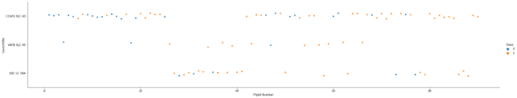

Figure : Visualize the relationship between Flight Number and Launch Site

### **TASK 2: Visualize the relationship between Payload and Launch Site**

We also want to observe if there is any relationship between launch sites and their payload mass.

In [11]:

*# Plot a scatter point chart with x axis to be Pay Load Mass (kg) and y axis to be the launch site, and hue to be the class value*

sns**.**catplot(x**=**"PayloadMass", y**=**"LaunchSite", hue**=**"Class", data**=**df, aspect **=** 5)

plt**.**xlabel("Flight Number")

plt**.**ylabel("LaunchSite")

plt**.**show()

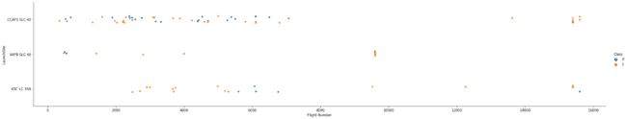

Figure : Visualize the relationship between Payload and Launch Site

Now if you observe Payload Vs. Launch Site scatter point chart you will find for the VAFB-SLC launchsite there are no rockets launched for heavypayload mass(greater than 10000).

### **TASK 3: Visualize the relationship between success rate of each orbit type**

Next, we want to visually check if there are any relationship between success rate and orbit type.

Let's create a bar chart for the sucess rate of each orbit

In [13]:

*# HINT use groupby method on Orbit column and get the mean of Class column*

Orbittype**=**df**.**groupby(by**=**"Orbit", axis**=**0)**.**mean()["Class"]

Orbittype**=**pd**.**DataFrame(Orbittype)

Orbittype['orbit'] **=** Orbittype**.**index

sns**.**catplot(x**=**"orbit", y**=**"Class", data**=**Orbittype, kind**=**"bar", aspect**=**5)

Out[13]:

<seaborn.axisgrid.FacetGrid at 0x7f2b5972d490>

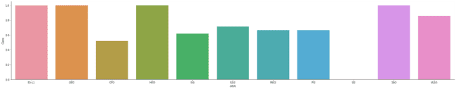

Figure : Visualize the relationship between success rate of each orbit type

Analyze the ploted bar chart try to find which orbits have high sucess rate.

### Explain the patterns - which orbits have high sucess rate.

***.*ES-L1, GEO, HEO, SSO has highest Sucess rates**. SO has poorest.

### **TASK 4: Visualize the relationship between FlightNumber and Orbit type**

For each orbit, we want to see if there is any relationship between FlightNumber and Orbit type.

In [14]:

*# Plot a scatter point chart with x axis to be FlightNumber and y axis to be the Orbit, and hue to be the class value*

sns**.**catplot(x**=**"FlightNumber", y**=**"Orbit", hue**=**"Class", data**=**df, aspect **=** 5)

plt**.**xlabel("Flight Number")

plt**.**ylabel("Orbit")

plt**.**show()

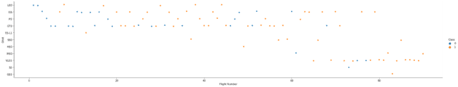

Figure : Visualize the relationship between success rate of each orbit type

You should see that in the LEO orbit the Success appears related to the number of flights; on the other hand, there seems to be no relationship between flight number when in GTO orbit.

### **TASK 5: Visualize the relationship between Payload and Orbit type**

Similarly, we can plot the Payload vs. Orbit scatter point charts to reveal the relationship between Payload and Orbit type

In [15]:

*# Plot a scatter point chart with x axis to be Payload and y axis to be the Orbit, and hue to be the class value*

sns**.**catplot(x**=**"PayloadMass", y**=**"Orbit", data**=**df, hue**=**"Class", aspect **=** 5)

plt**.**xlabel("PayloadMass")

plt**.**ylabel("Orbit")

plt**.**show()

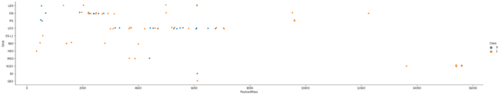

Figure : Visualize the relationship between Payload and Orbit type

With heavy payloads the successful landing or positive landing rate are more for Polar,LEO and ISS.

However for GTO we cannot distinguish this well as both positive landing rate and negative landing(unsuccessful mission) are both there here.

### **TASK 6: Visualize the launch success yearly trend**

You can plot a line chart with x axis to be Year and y axis to be average success rate, to get the average launch success trend.

The function will help you get the year from the date:

In [19]:

*# A function to Extract years from the date*

year**=**[]

**def** Extract_year(date):

**for** i **in** df["Date"]:

year**.**append(i**.**split("-")[0])

**return** year

df['year']**=**Extract_year(df)

by_year**=**df**.**groupby(by**=**"year", axis**=**0)**.**mean()["Class"]

by_year **=** pd**.**DataFrame(by_year)

by_year**.**reset_index(level**=**0, inplace**=True**)

by_year

Out[19]:

Table : Data Years from the date

|  | **year** | **Class** |
| --- | --- | --- |
| **0** | 2010 | 0.000000 |
| **1** | 2012 | 0.000000 |
| **2** | 2013 | 0.000000 |
| **3** | 2014 | 0.333333 |
| **4** | 2015 | 0.333333 |
| **5** | 2016 | 0.625000 |
| **6** | 2017 | 0.833333 |
| **7** | 2018 | 0.611111 |
| **8** | 2019 | 0.900000 |
| **9** | 2020 | 0.842105 |

In [20]:

*# Plot a line chart with x axis to be the extracted year and y axis to be the success rate*

sns**.**lineplot( x**=**"year", y**=**"Class", data**=**by_year)

plt**.**xlabel("year")

plt**.**ylabel("class")

plt**.**show()

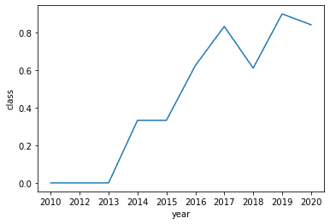

Figure : Visualize the launch success yearly trend

you can observe that the success rate since 2013 kept increasing till 2020

## Features Engineering

By now, you should obtain some preliminary insights about how each important variable would affect the success rate, we will select the features that will be used in success prediction in the future module.

In [27]:

features **=** df[['FlightNumber', 'PayloadMass', 'Orbit', 'LaunchSite', 'Flights', 'GridFins', 'Reused', 'Legs', 'LandingPad', 'Block', 'ReusedCount', 'Serial']]

features**.**head()

Out[27]:

Table :

|  | **FlightNumber** | **PayloadMass** | **Orbit** | **LaunchSite** | **Flights** | **GridFins** | **Reused** | **Legs** | **LandingPad** | **Block** | **ReusedCount** | **Serial** |
| --- | --- | --- | --- | --- | --- | --- | --- | --- | --- | --- | --- | --- |
| **0** | 1 | 6104.959412 | LEO | CCAFS SLC 40 | 1 | False | False | False | NaN | 1.0 | 0 | B0003 |
| **1** | 2 | 525.000000 | LEO | CCAFS SLC 40 | 1 | False | False | False | NaN | 1.0 | 0 | B0005 |
| **2** | 3 | 677.000000 | ISS | CCAFS SLC 40 | 1 | False | False | False | NaN | 1.0 | 0 | B0007 |
| **3** | 4 | 500.000000 | PO | VAFB SLC 4E | 1 | False | False | False | NaN | 1.0 | 0 | B1003 |
| **4** | 5 | 3170.000000 | GTO | CCAFS SLC 40 | 1 | False | False | False | NaN | 1.0 | 0 | B1004 |

### **TASK 7: Create dummy variables to categorical columns**

Use the function get_dummies and features dataframe to apply OneHotEncoder to the column Orbits, LaunchSite, LandingPad, and Serial. Assign the value to the variable features_one_hot, display the results using the method head. Your result dataframe must include all features including the encoded ones.

In [29]:

*# HINT: Use get_dummies() function on the categorical columns*

features_one_hot **=** pd**.**get_dummies(features[['Orbit','LaunchSite','LandingPad','Serial']])

features_one_hot**.**head()

Out[29]:

Table :

|  | **Orbit_ES-L1** | **Orbit_GEO** | **Orbit_GTO** | **Orbit_HEO** | **Orbit_ISS** | **Orbit_LEO** | **Orbit_MEO** | **Orbit_PO** | **Orbit_SO** | **Orbit_SSO** | **...** | **Serial_B1048** | **Serial_B1049** | **Serial_B1050** | **Serial_B1051** | **Serial_B1054** | **Serial_B1056** | **Serial_B1058** | **Serial_B1059** | **Serial_B1060** | **Serial_B1062** |
| --- | --- | --- | --- | --- | --- | --- | --- | --- | --- | --- | --- | --- | --- | --- | --- | --- | --- | --- | --- | --- | --- |
| **0** | 0 | 0 | 0 | 0 | 0 | 1 | 0 | 0 | 0 | 0 | ... | 0 | 0 | 0 | 0 | 0 | 0 | 0 | 0 | 0 | 0 |
| **1** | 0 | 0 | 0 | 0 | 0 | 1 | 0 | 0 | 0 | 0 | ... | 0 | 0 | 0 | 0 | 0 | 0 | 0 | 0 | 0 | 0 |
| **2** | 0 | 0 | 0 | 0 | 1 | 0 | 0 | 0 | 0 | 0 | ... | 0 | 0 | 0 | 0 | 0 | 0 | 0 | 0 | 0 | 0 |
| **3** | 0 | 0 | 0 | 0 | 0 | 0 | 0 | 1 | 0 | 0 | ... | 0 | 0 | 0 | 0 | 0 | 0 | 0 | 0 | 0 | 0 |
| **4** | 0 | 0 | 1 | 0 | 0 | 0 | 0 | 0 | 0 | 0 | ... | 0 | 0 | 0 | 0 | 0 | 0 | 0 | 0 | 0 | 0 |

5 rows × 72 columns

### **TASK 8: Cast all numeric columns to float64**

Now that our **features_one_hot** dataframe only contains numbers cast the entire dataframe to variable type float64

In [30]:

*# HINT: use astype function*

features_one_hot **=** features_one_hot**.**astype(float)

features_one_hot

|  | **FlightNumber** | **PayloadMass** | **Flights** | **GridFins** | **Reused** | **Legs** | **Block** | **ReusedCount** | **ES-L1** | **GEO** | **...** | **B1048** | **B1049** | **B1050** | **B1051** | **B1054** | **B1056** | **B1058** | **B1059** | **B1060** | **B1062** |
| --- | --- | --- | --- | --- | --- | --- | --- | --- | --- | --- | --- | --- | --- | --- | --- | --- | --- | --- | --- | --- | --- |
| **0** | 1.0 | 6104.959412 | 1.0 | 0.0 | 0.0 | 0.0 | 1.0 | 0.0 | 0.0 | 0.0 | ... | 0.0 | 0.0 | 0.0 | 0.0 | 0.0 | 0.0 | 0.0 | 0.0 | 0.0 | 0.0 |
| **1** | 2.0 | 525.000000 | 1.0 | 0.0 | 0.0 | 0.0 | 1.0 | 0.0 | 0.0 | 0.0 | ... | 0.0 | 0.0 | 0.0 | 0.0 | 0.0 | 0.0 | 0.0 | 0.0 | 0.0 | 0.0 |
| **2** | 3.0 | 677.000000 | 1.0 | 0.0 | 0.0 | 0.0 | 1.0 | 0.0 | 0.0 | 0.0 | ... | 0.0 | 0.0 | 0.0 | 0.0 | 0.0 | 0.0 | 0.0 | 0.0 | 0.0 | 0.0 |
| **3** | 4.0 | 500.000000 | 1.0 | 0.0 | 0.0 | 0.0 | 1.0 | 0.0 | 0.0 | 0.0 | ... | 0.0 | 0.0 | 0.0 | 0.0 | 0.0 | 0.0 | 0.0 | 0.0 | 0.0 | 0.0 |
| **4** | 5.0 | 3170.000000 | 1.0 | 0.0 | 0.0 | 0.0 | 1.0 | 0.0 | 0.0 | 0.0 | ... | 0.0 | 0.0 | 0.0 | 0.0 | 0.0 | 0.0 | 0.0 | 0.0 | 0.0 | 0.0 |
| **...** | ... | ... | ... | ... | ... | ... | ... | ... | ... | ... | ... | ... | ... | ... | ... | ... | ... | ... | ... | ... | ... |
| **85** | 86.0 | 15400.000000 | 2.0 | 1.0 | 1.0 | 1.0 | 5.0 | 2.0 | 0.0 | 0.0 | ... | 0.0 | 0.0 | 0.0 | 0.0 | 0.0 | 0.0 | 0.0 | 0.0 | 1.0 | 0.0 |
| **86** | 87.0 | 15400.000000 | 3.0 | 1.0 | 1.0 | 1.0 | 5.0 | 2.0 | 0.0 | 0.0 | ... | 0.0 | 0.0 | 0.0 | 0.0 | 0.0 | 0.0 | 1.0 | 0.0 | 0.0 | 0.0 |
| **87** | 88.0 | 15400.000000 | 6.0 | 1.0 | 1.0 | 1.0 | 5.0 | 5.0 | 0.0 | 0.0 | ... | 0.0 | 0.0 | 0.0 | 1.0 | 0.0 | 0.0 | 0.0 | 0.0 | 0.0 | 0.0 |
| **88** | 89.0 | 15400.000000 | 3.0 | 1.0 | 1.0 | 1.0 | 5.0 | 2.0 | 0.0 | 0.0 | ... | 0.0 | 0.0 | 0.0 | 0.0 | 0.0 | 0.0 | 0.0 | 0.0 | 1.0 | 0.0 |
| **89** | 90.0 | 3681.000000 | 1.0 | 1.0 | 0.0 | 1.0 | 5.0 | 0.0 | 0.0 | 0.0 | ... | 0.0 | 0.0 | 0.0 | 0.0 | 0.0 | 0.0 | 0.0 | 0.0 | 0.0 | 1.0 |

90 rows × 80 columns

Out[30]:

We can now export it to a **CSV** for the next section,but to make the answers consistent, in the next lab we will provide data in a pre-selected date range.

In [31]:

features_one_hot**.**to_csv('dataset_part\_3.csv', index**=False**)

features_one_hot.to_csv('dataset_part\_3.csv', index=False)

## Authors

[Joseph Santarcangelo](https://www.linkedin.com/in/joseph-s-50398b136/?utm_medium=Exinfluencer&utm_source=Exinfluencer&utm_content=000026UJ&utm_term=10006555&utm_id=NA-SkillsNetwork-Channel-SkillsNetworkCoursesIBMDS0321ENSkillsNetwork26802033-2021-01-01) has a PhD in Electrical Engineering, his research focused on using machine learning, signal processing, and computer vision to determine how videos impact human cognition. Joseph has been working for IBM since he completed his PhD.

[Nayef Abou Tayoun](https://www.linkedin.com/in/nayefaboutayoun/?utm_medium=Exinfluencer&utm_source=Exinfluencer&utm_content=000026UJ&utm_term=10006555&utm_id=NA-SkillsNetwork-Channel-SkillsNetworkCoursesIBMDS0321ENSkillsNetwork26802033-2021-01-01) is a Data Scientist at IBM and pursuing a Master of Management in Artificial intelligence degree at Queen's University.

## Change Log

Table : Week 2.2 Change log

| **Date (YYYY-MM-DD)** | **Version** | **Changed By** | **Change Description** |
| --- | --- | --- | --- |
| 2021-10-12 | 1.1 | Lakshmi Holla | Modified markdown |
| 2020-09-20 | 1.0 | Joseph | Modified Multiple Areas |
| 2020-11-10 | 1.1 | Nayef | updating the input data |

## 3️⃣Chapter 3: Interactive Visual Analytics and Dashboard

**3.1:**[**Interactive Visual Analytics with Folium**](https://github.com/sachinrathi1997/SpaceX_DS_Project/blob/main/lab_jupyter_launch_site_location.ipynb)

# ****Launch Sites Locations Analysis with Folium****

Estimated time needed: **40** minutes

The launch success rate may depend on many factors such as payload mass, orbit type, and so on. It may also depend on the location and proximities of a launch site, i.e., the initial position of rocket trajectories. Finding an optimal location for building a launch site certainly involves many factors and hopefully we could discover some of the factors by analyzing the existing launch site locations.

In the previous exploratory data analysis labs, you have visualized the SpaceX launch dataset using matplotlib and seaborn and discovered some preliminary correlations between the launch site and success rates. In this lab, you will be performing more interactive visual analytics using Folium.

## Objectives

This lab contains the following tasks:

* **TASK 1:** Mark all launch sites on a map
* **TASK 2:** Mark the success/failed launches for each site on the map
* **TASK 3:** Calculate the distances between a launch site to its proximities

After completed the above tasks, you should be able to find some geographical patterns about launch sites.

Let's first import required Python packages for this lab:

In [1]:

**!**pip3 install folium

**!**pip3 install wget

Requirement already satisfied: folium in /Users/debdattasarkar/opt/anaconda3/lib/python3.8/site-packages (0.12.1)

Requirement already satisfied: branca>=0.3.0 in /Users/debdattasarkar/opt/anaconda3/lib/python3.8/site-packages (from folium) (0.4.2)

Requirement already satisfied: requests in /Users/debdattasarkar/opt/anaconda3/lib/python3.8/site-packages (from folium) (2.25.1)

Requirement already satisfied: jinja2>=2.9 in /Users/debdattasarkar/opt/anaconda3/lib/python3.8/site-packages (from folium) (2.11.3)

Requirement already satisfied: numpy in /Users/debdattasarkar/opt/anaconda3/lib/python3.8/site-packages (from folium) (1.20.1)

Requirement already satisfied: MarkupSafe>=0.23 in /Users/debdattasarkar/opt/anaconda3/lib/python3.8/site-packages (from jinja2>=2.9->folium) (1.1.1)

Requirement already satisfied: urllib3<1.27,>=1.21.1 in /Users/debdattasarkar/opt/anaconda3/lib/python3.8/site-packages (from requests->folium) (1.26.4)

Requirement already satisfied: idna<3,>=2.5 in /Users/debdattasarkar/opt/anaconda3/lib/python3.8/site-packages (from requests->folium) (2.10)

Requirement already satisfied: certifi>=2017.4.17 in /Users/debdattasarkar/opt/anaconda3/lib/python3.8/site-packages (from requests->folium) (2020.12.5)

Requirement already satisfied: chardet<5,>=3.0.2 in /Users/debdattasarkar/opt/anaconda3/lib/python3.8/site-packages (from requests->folium) (4.0.0)

Requirement already satisfied: wget in /Users/debdattasarkar/opt/anaconda3/lib/python3.8/site-packages (3.2)

In [2]:

**import** folium

**import** wget

**import** pandas **as** pd

In [3]:

*# Import folium MarkerCluster plugin*

**from** folium.plugins **import** MarkerCluster

*# Import folium MousePosition plugin*

**from** folium.plugins **import** MousePosition

*# Import folium DivIcon plugin*

**from** folium.features **import** DivIcon

## Task 1: Mark all launch sites on a map

First, let's try to add each site's location on a map using site's latitude and longitude coordinates

The following dataset with the name spacex_launch_geo.csv is an augmented dataset with latitude and longitude added for each site.

In [4]:

*# Download and read the `spacex_launch_geo.csv`*

spacex_csv_file **=** wget**.**download('https://cf-courses-data.s3.us.cloud-object-storage.appdomain.cloud/IBM-DS0321EN-SkillsNetwork/datasets/spacex_launch_geo.csv')

spacex_df**=**pd**.**read_csv(spacex_csv_file)

Now, you can take a look at what are the coordinates for each site.

In [5]:

*# Select relevant sub-columns: `Launch Site`, `Lat(Latitude)`, `Long(Longitude)`, `class`*

spacex_df **=** spacex_df[['Launch Site', 'Lat', 'Long', 'class']]

launch_sites_df **=** spacex_df**.**groupby(['Launch Site'], as_index**=False**)**.**first()

launch_sites_df **=** launch_sites_df[['Launch Site', 'Lat', 'Long']]

launch_sites_df

Out[5]:

Table : Mark all launch sites on a map

|  | **Launch Site** | **Lat** | **Long** |
| --- | --- | --- | --- |
| **0** | CCAFS LC-40 | 28.562302 | -80.577356 |
| **1** | CCAFS SLC-40 | 28.563197 | -80.576820 |
| **2** | KSC LC-39A | 28.573255 | -80.646895 |
| **3** | VAFB SLC-4E | 34.632834 | -120.610746 |

Above coordinates are just plain numbers that cannot give you any intuitive insights about where those are launch sites. If you are very good at geography, you can interpret those numbers directly in your mind. If not, that's fine too. Let's visualize those locations by pinning them on a map.

We first need to create a folium Map object, with an initial centre location to be NASA Johnson Space Centre at Houston, Texas.

In [6]:

*# Start location is NASA Johnson Space Center*

nasa_coordinate **=** [29.559684888503615, **-**95.0830971930759]

site_map **=** folium**.**Map(location**=**nasa_coordinate, zoom_start**=**10)

We could use folium.Circle to add a highlighted circle area with a text label on a specific coordinate. For example,

In [7]:

*# Create a blue circle at NASA Johnson Space Center's coordinate with a popup label showing its name*

*# Circle should be blue so changing color code from #d35400 to #2572e6*

circle **=** folium**.**Circle(nasa_coordinate, radius**=**1000, color**=**'#2572e6', fill**=True**)**.**add_child(folium**.**Popup('NASA Johnson Space Center'))

*# Create a blue circle at NASA Johnson Space Center's coordinate with a icon showing its name*

marker **=** folium**.**map**.**Marker(

nasa_coordinate,

*# Create an icon as a text label*

icon**=**DivIcon(

icon_size**=**(20,20),

icon_anchor**=**(0,0),

html**=**'<div style="font-size: 12; color:#d35400;"><b>%s</b></div>' **%** 'NASA JSC',

)

)

site_map**.**add_child(circle)

site_map**.**add_child(marker)

Out[7]:

Make this Notebook Trusted to load map: File -> Trust Notebook

and you should find a small yellow circle near the city of Houston, and you can zoom-in to see a larger circle.

Now, let's add a circle for each launch site in data frame **launch_sites**

TODO: Create and add **folium.Circle** and **folium.Marker** for each launch site on the site map

#### Converting the dataframe to dictionary

In [8]:

launch_sites_dict **=** launch_sites_df**.**set_index('Launch Site')**.**T**.**to_dict('list')

launch_sites_dict

Out[8]:

{'CCAFS LC-40': [28.56230196799018, -80.57735647504778],

'CCAFS SLC-40': [28.563197177407144, -80.57682003124195],

'KSC LC-39A': [28.57325457037815, -80.64689528960382],

'VAFB SLC-4E': [34.632834161782775, -120.61074553068327]}

# My Own Custom Functions for Markers

In [9]:

**def** add_marker_on_map(name, coordinate, circle_color**=**'#d35400'):

circle **=** folium**.**Circle(coordinate, radius**=**1000, color**=**circle_color, fill**=True**)**.**add_child(folium**.**Popup(name))

marker **=** folium**.**map**.**Marker(

coordinate,

icon**=**DivIcon(

icon_size**=**(20,20),

icon_anchor**=**(0,0),

html**=**"<div style='font-size: 12; color:{};'><b>{}</b></div>"**.** format(circle_color,name)

)

)

site_map**.**add_child(circle)

site_map**.**add_child(marker)

**def** add_text_distance_marker_on_map(name, coordinate, distance, ccolor**=**'#4d0f1d'):

txt**=**"{}, {:0.2f} km"**.**format(name, distance)

folium**.**Marker(

location**=**coordinate,

icon**=**DivIcon(

icon_size**=**(150,30),

icon_anchor**=**(0,0),

html**=**'<div style="font-size: 9pt; font-weight:bold; color: {}">{}</div>'**.**format(ccolor, txt))

)**.**add_to(site_map)

**def** add_type_marker_on_map(name, coordinate, ccolor**=**'red', icon_type**=**'train'):

marker **=** folium**.**map**.**Marker(

location**=**coordinate,

popup**=**name,

tooltip**=**'click',

icon**=**folium**.**Icon(color**=**ccolor, icon**=**icon_type, prefix**=**'fa')

)

site_map**.**add_child(marker)

**def** add_type_distance_marker_on_map(name, coordinate, distance, ccolor**=**'red', icon_type**=**'bolt'):

text **=** "{} {:0.2f}km"**.**format(name, distance)

marker **=** folium**.**map**.**Marker(

location**=**coordinate,

popup**=**text,

icon**=**folium**.**Icon(color**=**ccolor, icon**=**icon_type, prefix**=**'fa')

)

site_map**.**add_child(marker)

**def** add_distance_marker_on_map(name, coordinate, distance, ccolor**=**'#8D208B'):

text **=** "{} {:0.2f}km"**.**format(name, distance)

marker **=** folium**.**map**.**Marker(

location**=**coordinate,

tooltip**=**text,

icon**=**plugins**.**BeautifyIcon(

number**=**round(distance,0),

border_color**=**ccolor,

border_width**=**2,

text_color**=**ccolor,

inner_icon_style**=**'margin-top:0px;')

)

site_map**.**add_child(marker)

**def** draw_distance_lines(place1, place2, lcolor**=**'blue', icolor**=**'red', tcolor**=**'#4d0f1d'):

add_type_marker_on_map(place2['name'], place2['coordinates'], ccolor**=**icolor, icon_type**=**place2['placetype'])

points**=**[]

points**.**append(place1['coordinates'])

points**.**append(place2['coordinates'])

distance **=** calculate_distance(place1['coordinates'][0], place1['coordinates'][1], place2['coordinates'][0], place2['coordinates'][1])

add_text_distance_marker_on_map(place2['name'], place2['coordinates'], distance, tcolor)

linetext **=** "{}{:0.2f} km"**.**format(place2['name'], distance)

*# folium.plugins.AntPath(points, color=lcolor, weight=1.5, delay = .5, popup=linetext).add_to(site_map)*

folium**.**PolyLine(points, color**=**lcolor, weight**=**1.5, popup**=**linetext)**.**add_to(site_map)

**def** draw_equater_line():

points**=**[]

points**.**append([0,195])

points**.**append([0,**-**450])

folium**.**plugins**.**AntPath(points, color**=**'green', weight**=**1.5, delay **=** .5)**.**add_to(site_map)

**def** add_marker_cluster_on_map(name, coordinate, color):

folium**.**Marker(

location**=**coordinate,

popup**=**name,

icon**=**folium**.**Icon(color**=**'white', icon_color**=**color),

)**.**add_to(marker_cluster)

In [10]:

*# Initial the map*

*# site_map = folium.Map(location=nasa_coordinate, zoom_start=5)*

*# Zooming on a launch site 'VAFB SLC-4E' rather than NASA for better visibiliy of work mentioned in below tasks.*

VAFB_SLC_4E **=** [34.632834, **-**120.610746]

site_map **=** folium**.**Map(location**=**VAFB_SLC_4E, zoom_start**=**3)

*# CCAFS_SLC_40 = [28.563197177407144, -80.57682003124195]*

*# site_map = folium.Map(location=CCAFS_SLC_40, zoom_start=5)*

*# For each launch site, add a Circle object based on its coordinate (Lat, Long) values. In addition, add Launch site name as a popup label*

**for** name,coordinate **in** launch_sites_dict**.**items():

add_marker_on_map(name, coordinate)

site_map

Out[10]:

Make this Notebook Trusted to load map: File -> Trust Notebook

The generated map with marked launch sites should look like the following:

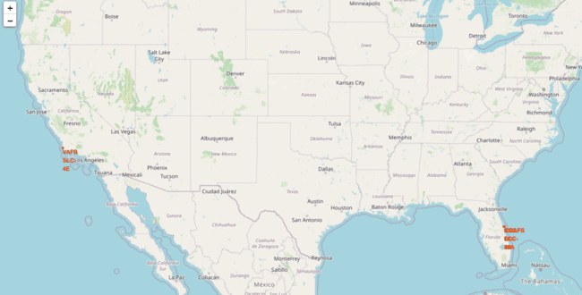

Figure : Mark all launch sites on a map

Now, you can explore the map by zoom-in/out the marked areas, and try to answer the following questions:

* Are all launch sites in proximity to the Equator line?
* Are all launch sites in very close proximity to the coast?

Also please try to explain your findings.

# Task 2: Mark the success/failed launches for each site on the map

Next, let's try to enhance the map by adding the launch outcomes for each site, and see which sites have high success rates. Recall that data frame spacex_df has detailed launch records, and the class column indicates if this launch was successful or not

In [11]:

spacex_df**.**tail(10)

Out[11]:

Table : Mark the success/failed launches for each site on the map

|  | **Launch Site** | **Lat** | **Long** | **class** |
| --- | --- | --- | --- | --- |
| **46** | KSC LC-39A | 28.573255 | -80.646895 | 1 |
| **47** | KSC LC-39A | 28.573255 | -80.646895 | 1 |
| **48** | KSC LC-39A | 28.573255 | -80.646895 | 1 |
| **49** | CCAFS SLC-40 | 28.563197 | -80.576820 | 1 |
| **50** | CCAFS SLC-40 | 28.563197 | -80.576820 | 1 |
| **51** | CCAFS SLC-40 | 28.563197 | -80.576820 | 0 |
| **52** | CCAFS SLC-40 | 28.563197 | -80.576820 | 0 |
| **53** | CCAFS SLC-40 | 28.563197 | -80.576820 | 0 |
| **54** | CCAFS SLC-40 | 28.563197 | -80.576820 | 1 |
| **55** | CCAFS SLC-40 | 28.563197 | -80.576820 | 0 |

Next, let's create markers for all launch records. If a launch was successful (class=1), then we use a green marker and if a launch was failed, we use a red marker (class=0)

Note that a launch only happens in one of the four launch sites, which means many launch records will have the exact same coordinate. Marker clusters can be a good way to simplify a map containing many markers having the same coordinate.

Let's first create a MarkerCluster object

In [12]:

marker_cluster **=** MarkerCluster()

TODO: Create a new column in launch_sites dataframe called marker_color to store the marker colors based on the class value

In [13]:

*# Apply a function to check the value of `class` column*

*# If class=1, marker_color value will be green*

*# If class=0, marker_color value will be red*

In [14]:

*# Function to assign color to launch outcome*

**def** assign_marker_color(launch_outcome):

**if** launch_outcome **==** 1:

**return** 'green'

**else**:

**return** 'red'

spacex_df['marker_color'] **=** spacex_df['class']**.**apply(assign_marker_color)

spacex_df**.**tail(10)

Out[14]:

Table : Mark the success/failed launches for each site on the map

|  | **Launch Site** | **Lat** | **Long** | **class** | **marker_color** |
| --- | --- | --- | --- | --- | --- |
| **46** | KSC LC-39A | 28.573255 | -80.646895 | 1 | green |
| **47** | KSC LC-39A | 28.573255 | -80.646895 | 1 | green |
| **48** | KSC LC-39A | 28.573255 | -80.646895 | 1 | green |
| **49** | CCAFS SLC-40 | 28.563197 | -80.576820 | 1 | green |
| **50** | CCAFS SLC-40 | 28.563197 | -80.576820 | 1 | green |
| **51** | CCAFS SLC-40 | 28.563197 | -80.576820 | 0 | red |
| **52** | CCAFS SLC-40 | 28.563197 | -80.576820 | 0 | red |
| **53** | CCAFS SLC-40 | 28.563197 | -80.576820 | 0 | red |
| **54** | CCAFS SLC-40 | 28.563197 | -80.576820 | 1 | green |
| **55** | CCAFS SLC-40 | 28.563197 | -80.576820 | 0 | red |

TODO: For each launch result in **spacex_df** data frame, add a **folium.Marker** to **marker_cluster**

In [15]:

launch_coordinates**=**spacex_df[['Lat','Long']]

color_list**=**spacex_df['marker_color']**.**values**.**tolist()

name_list**=**spacex_df['Launch Site']**.**values**.**tolist()

coordinate_list**=**launch_coordinates**.**values**.**tolist()

*# for each row in spacex_df data frame*

*# create a Marker object with its coordinate*

*# and customize the Marker's icon property to indicate if this launch was successed or failed, e.g., icon=folium.Icon(color='white', icon_color=row['marker_color']*

**for** i **in** range(len(coordinate_list)):

name **=** name_list[i]

coordinate **=** coordinate_list[i]

color **=** color_list[i]

add_marker_cluster_on_map(name, coordinate, color)

*# Add the Marker cluster to the site map*

site_map**.**add_child(marker_cluster)

Out[15]:

Make this Notebook Trusted to load map: File -> Trust Notebook

Your updated map may look like the following screenshots:

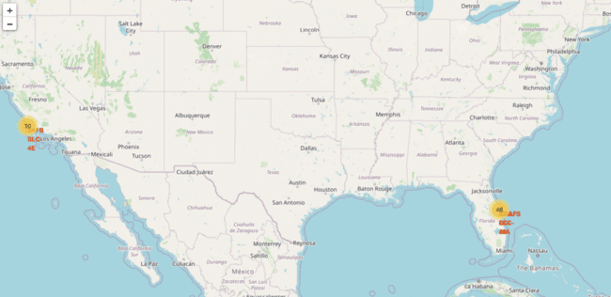

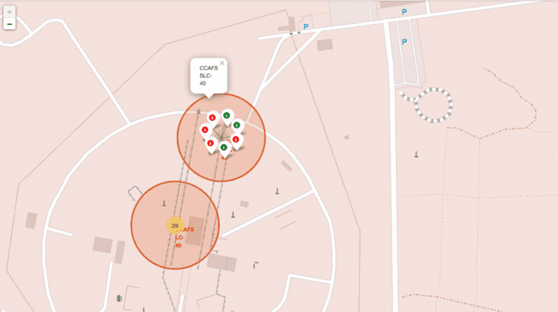

Figure : Mark the success/failed launches for each site on the map

From the color-labeled markers in marker clusters, you should be able to easily identify which launch sites have relatively high success rates.

# TASK 3: Calculate the distances between a launch site to its proximities

Next, we need to explore and analyze the proximities of launch sites.

Let's first add a **MousePosition** on the map to get coordinate for a mouse over a point on the map. As such, while you are exploring the map, you can easily find the coordinates of any points of interests (such as railway)

In [16]:

*# Add Mouse Position to get the coordinate (Lat, Long) for a mouse over on the map*

formatter **=** "function(num) {return L.Util.formatNum(num, 5);};"

mouse_position **=** MousePosition(

position**=**'topright',

separator**=**' Long: ',

empty_string**=**'NaN',

lng_first**=False**,

num_digits**=**20,

prefix**=**'Lat:',

lat_formatter**=**formatter,

lng_formatter**=**formatter,

)

site_map**.**add_child(mouse_position)

site_map

Out[16]:

Make this Notebook Trusted to load map: File -> Trust Notebook

Now zoom in to a launch site and explore its proximity to see if you can easily find any railway, highway, coastline, etc. Move your mouse to these points and mark down their coordinates (shown on the top-left) in order to the distance to the launch site.

You can calculate the distance between two points on the map based on their Lat and Long values using the following method:

In [17]:

**from** math **import** sin, cos, sqrt, atan2, radians

**def** calculate_distance(lat1, lon1, lat2, lon2):

*# approximate radius of earth in km*

R **=** 6373.0

lat1 **=** radians(lat1)

lon1 **=** radians(lon1)

lat2 **=** radians(lat2)

lon2 **=** radians(lon2)

dlon **=** lon2 **-** lon1

dlat **=** lat2 **-** lat1

a **=** sin(dlat **/** 2)**\*\***2 **+** cos(lat1) **\*** cos(lat2) **\*** sin(dlon **/** 2)**\*\***2

c **=** 2 **\*** atan2(sqrt(a), sqrt(1 **-** a))

distance **=** R **\*** c

**return** distance

TODO: Mark down a point on the closest railway using MousePosition and calculate the distance between the railway point to the launch site.

In [18]:

spacex_df[spacex_df['Launch Site'] **==** 'VAFB SLC-4E']

Out[18]:

Table : Calculate the distances between a launch site to its proximities

|  | **Launch Site** | **Lat** | **Long** | **class** | **marker_color** |
| --- | --- | --- | --- | --- | --- |
| **26** | VAFB SLC-4E | 34.632834 | -120.610746 | 0 | red |
| **27** | VAFB SLC-4E | 34.632834 | -120.610746 | 0 | red |
| **28** | VAFB SLC-4E | 34.632834 | -120.610746 | 1 | green |
| **29** | VAFB SLC-4E | 34.632834 | -120.610746 | 1 | green |
| **30** | VAFB SLC-4E | 34.632834 | -120.610746 | 1 | green |
| **31** | VAFB SLC-4E | 34.632834 | -120.610746 | 1 | green |
| **32** | VAFB SLC-4E | 34.632834 | -120.610746 | 0 | red |
| **33** | VAFB SLC-4E | 34.632834 | -120.610746 | 0 | red |
| **34** | VAFB SLC-4E | 34.632834 | -120.610746 | 0 | red |
| **35** | VAFB SLC-4E | 34.632834 | -120.610746 | 0 | red |

In [19]:

*# distance_railway = calculate_distance(lat1, lon1, lat2, lon2)*

*# Launch Site -*

*# VAFB SLC-4E 34.632834 -120.610746*

*# Railway Station -*

*# Guadalupe Amtrak Station/Coordinates*

*# 34.9629 -120.5733*

*# guadalupe_amtrak = [34.9629, -120.5733]*

*# VAFB_SLC_4E = [34.632834, -120.610746]*

*# distance_railway = calculate_distance(guadalupe_amtrak[0], guadalupe_amtrak[1], VAFB_SLC_4E[0], VAFB_SLC_4E[1])*

*# distance_railway*

TODO: After obtained its coordinate, create a folium.Marker to show the distance

In [20]:

*# create and add a folium.Marker on your selected closest raiwaly point on the map*

*# show the distance to the launch site using the icon property*

*# railway_name = "Guadalupe Amtrak Station, {:0.2f} km".format(distance_railway)*

*# add_type_marker_on_map(railway_name, guadalupe_amtrak, ccolor='green', icon_type='train')*

*# railway_name = "Guadalupe Amtrak Station"*

*# add_distance_marker_on_map(railway_name, guadalupe_amtrak, distance_railway)*

*# add_type_distance_marker_on_map(railway_name, guadalupe_amtrak, distance_railway, ccolor='green', icon_type='train')*

TODO: Draw a PolyLine between a launch site to the selected

In [21]:

*# Create a `folium.PolyLine` object using the railway point coordinate and launch site coordinate*

*# points=[]*

*# points.append(VAFB_SLC_4E)*

*# points.append(guadalupe_amtrak)*

*# linetext = "{}, {:0.2f} km".format(railway_name, distance_railway)*

*# folium.PolyLine(points, color='blue', weight=2.5, popup=linetext).add_to(site_map)*

*# add_text_distance_marker_on_map(railway_name, guadalupe_amtrak, distance_railway, ccolor='#4d0f1d')*

*# site_map*

draw_equater_line()

launchsite_VAFB **=** {'name':'VAFB SLC-4E', 'coordinates':[34.632834, **-**120.610746], 'placetype':'rocket'}

equator1 **=** {'name':'Equator Distance from VAFB SLC-4E', 'coordinates':[0, **-**120.61], 'placetype':'map'}

draw_distance_lines(launchsite_VAFB, equator1,'green', 'green', '#325931')

launchsite_KSC **=** {'name':'KSC LC-39A', 'coordinates':[28.573255, **-**80.646895], 'placetype':'rocket'}

equator2 **=** {'name':'Equator Distance from KSC LC-39A', 'coordinates':[0, **-**80.64651], 'placetype':'map'}

draw_distance_lines(launchsite_KSC, equator2, 'green', 'green', '#325931')

site_map

Out[21]:

Make this Notebook Trusted to load map: File -> Trust Notebook

Your updated map with distance line should look like the following screenshot:

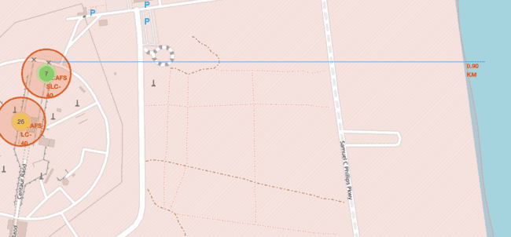

Figure : Calculate the distances between a launch site to its proximities

TODO: Similarly, you can draw a line betwee a launch site to its closest city, coastline, highway, etc.

In [22]:

*# Create a marker with distance to a closest city, coastline, highway, etc.*

*# Draw a line between the marker to the launch site*

launchsite_VAFB_railway **=** {'name':'Railway -', 'coordinates':[34.63141, **-**120.62568], 'placetype':'train'}

draw_distance_lines(launchsite_VAFB, launchsite_VAFB_railway, 'darkgreen', 'green', '#325931')

launchsite_VAFB_highway **=** {'name':'Highway -', 'coordinates':[34.66992, **-**120.45753], 'placetype':'road'}

draw_distance_lines(launchsite_VAFB, launchsite_VAFB_highway,'brown', 'darkred', '#823604')

launchsite_VAFB_coastline **=** {'name':'Coastline -', 'coordinates':[34.6336, **-**120.62606], 'placetype':'life-ring'}

draw_distance_lines(launchsite_VAFB, launchsite_VAFB_coastline,'darkblue', 'darkblue', '#00237d')

launchsite_VAFB_city **=** {'name':'City -', 'coordinates':[34.63658, **-**120.4542], 'placetype':'building'}

draw_distance_lines(launchsite_VAFB, launchsite_VAFB_city,'orange', 'orange', '#995700')

site_map

Out[22]:

Make this Notebook Trusted to load map: File -> Trust Notebook

In [23]:

launchsite_KSC_railway **=** {'name':'Railway -', 'coordinates':[28.573255, **-**80.65411], 'placetype':'train'}

draw_distance_lines(launchsite_KSC, launchsite_KSC_railway, 'darkgreen', 'green', '#325931')

launchsite_KSC_highway **=** {'name':'Highway -', 'coordinates':[28.573255, **-**80.646895], 'placetype':'road'}

draw_distance_lines(launchsite_KSC, launchsite_KSC_highway, 'brown', 'darkred', '#823604')

launchsite_KSC_coastline **=** {'name':'Coastline -', 'coordinates':[28.573255, **-**80.60669], 'placetype':'life-ring'}

draw_distance_lines(launchsite_KSC, launchsite_KSC_coastline, 'darkblue', 'darkblue', '#00237d')

launchsite_KSC_city **=** {'name':'City -', 'coordinates':[28.53748, **-**81.38672], 'placetype':'building'}

draw_distance_lines(launchsite_KSC, launchsite_KSC_city, 'orange', 'orange', '#995700')

site_map

Out[23]:

Make this Notebook Trusted to load map: File -> Trust Notebook

In [24]:

launchsite_CCAFS_SLC **=** {'name':'CCAFS SLC-40', 'coordinates':[28.563197, **-**80.576820], 'placetype':'rocket'}

launchsite_CCAFS_SLC_railway **=** {'name':'Railway -', 'coordinates':[28.57367, **-**80.58472], 'placetype':'train'}

launchsite_CCAFS_SLC_highway **=** {'name':'Highway -', 'coordinates':[28.563197, **-**80.64651], 'placetype':'road'}

launchsite_CCAFS_SLC_coastline **=** {'name':'Coastline -', 'coordinates':[28.563197, **-**80.56772], 'placetype':'life-ring'}

launchsite_CCAFS_SLC_city **=** {'name':'City -', 'coordinates':[28.66288, **-**81.35925], 'placetype':'building'}

draw_distance_lines(launchsite_CCAFS_SLC, launchsite_CCAFS_SLC_railway, 'darkgreen', 'green', '#325931')

draw_distance_lines(launchsite_CCAFS_SLC, launchsite_CCAFS_SLC_highway, 'brown', 'darkred', '#823604')

draw_distance_lines(launchsite_CCAFS_SLC, launchsite_CCAFS_SLC_coastline, 'darkblue', 'darkblue', '#00237d')

draw_distance_lines(launchsite_CCAFS_SLC, launchsite_CCAFS_SLC_city, 'orange', 'orange', '#995700')

site_map

Out[24]:

Make this Notebook Trusted to load map: File -> Trust Notebook

After you plot distance lines to the proximities, you can answer the following questions easily:

* Are launch sites in close proximity to railways?
* Are launch sites in close proximity to highways?
* Are launch sites in close proximity to coastline?
* Do launch sites keep certain distance away from cities?

Also please try to explain your findings.

# Next Steps:

Now you have discovered many interesting insights related to the launch sites' location using folium, in a very interactive way. Next, you will need to build a dashboard using Ploty Dash on detailed launch records.

## Authors

[Yan Luo](https://www.linkedin.com/in/yan-luo-96288783/?utm_medium=Exinfluencer&utm_source=Exinfluencer&utm_content=000026UJ&utm_term=10006555&utm_id=NA-SkillsNetwork-Channel-SkillsNetworkCoursesIBMDS0321ENSkillsNetwork26802033-2021-01-01)

### Other Contributors

Joseph Santarcangelo

## Change Log

Table : Week 3.1 Change Log

| **Date (YYYY-MM-DD)** | **Version** | **Changed By** | **Change Description** |
| --- | --- | --- | --- |
| 2021-05-26 | 1.0 | Yan | Created the initial version |

**3.2:** [**Plotly**](https://github.com/sachinrathi1997/SpaceX_DS_Project/blob/main/app.py)

|  |
| --- |
| ''' |
|  | Build a Dashboard Application with Plotly Dash |
|  | ---------------------------------------------- |
|  | In this lab, you will be building a Plotly Dash |
|  | application for users to perform interactive visual analytics |
|  | on SpaceX launch data in real-time. |
|  | ''' |
|  | import dash |
|  | import dash_html_components as html |
|  | import dash_core_components as dcc |
|  | from dash.dependencies import Input, Output |
|  | import pandas as pd |
|  | import plotly.express as px |
|  |  |
|  | external_stylesheets = ['https://codepen.io/chriddyp/pen/bWLwgP.css'] |
|  | app = dash.Dash(__name__, external_stylesheets=external_stylesheets) |
|  |  |
|  | spacex_df = pd.read_csv("spacex_launch_dash.csv") |
|  | max_payload = spacex_df['Payload Mass (kg)'].max() |
|  | min_payload = spacex_df['Payload Mass (kg)'].min() |
|  |  |
|  | unique_launch_sites = spacex_df['Launch Site'].unique().tolist() |
|  | launch_sites = [] |
|  | launch_sites.append({'label': 'All Sites', 'value': 'All Sites'}) |
|  | for launch_site in unique_launch_sites: |
|  | launch_sites.append({'label': launch_site, 'value': launch_site}) |
|  |  |
|  | app.layout = html.Div(children=[ |
|  | html.Div([ |
|  | html.H1('SpaceX Launch Records Dashboard', |
|  | style={'textAlign': 'center', 'color': '#503D36','font-size': 40}), |
|  | ]), |
|  |  |
|  | html.Div([ |
|  | # TASK 1: Add a Launch Site Drop-down Input Component |
|  | dcc.Dropdown( |
|  | id = 'site-dropdown', |
|  | options = launch_sites, |
|  | placeholder = 'Select a Launch Site here', |
|  | searchable = True , |
|  | clearable = False, |
|  | value = 'All Sites' |
|  | ), |
|  | # TASK 2: Add a callback function to render success-pie-chart based on selected site dropdown |
|  | html.Div(dcc.Graph(id='success-pie-chart')), |
|  | ], style={'padding': '0 30px'}), |
|  |  |
|  | html.Div([ |
|  | # TASK 3: Add a Range Slider to Select Payload |
|  | html.Div("Payload range (Kg):", |
|  | style={'color': '#503D36','font-size': 20, 'padding': '0 30px', 'margin-left': '11px'} |
|  | ), |
|  | html.Div([ |
|  | dcc.RangeSlider( |
|  | id = 'payload_slider', |
|  | min = 0, |
|  | max = 10000, |
|  | step = 1000, |
|  | marks = { |
|  | 0: {'label': '0 Kg', 'style': {'color': '#77b0b1'}}, |
|  | 1000: {'label': '1000 Kg'}, |
|  | 2000: {'label': '2000 Kg'}, |
|  | 3000: {'label': '3000 Kg'}, |
|  | 4000: {'label': '4000 Kg'}, |
|  | 5000: {'label': '5000 Kg'}, |
|  | 6000: {'label': '6000 Kg'}, |
|  | 7000: {'label': '7000 Kg'}, |
|  | 8000: {'label': '8000 Kg'}, |
|  | 9000: {'label': '9000 Kg'}, |
|  | 10000: {'label': '10000 Kg', 'style': {'color': '#f50'}}, |
|  | }, |
|  | value = [min_payload,max_payload] |
|  | ), |
|  | ], style={'padding': '40px 30px'}), |
|  |  |
|  | # TASK 4: Add a callback function to render the success-payload-scatter-chart scatter plot |
|  | html.Div(dcc.Graph(id = 'success-payload-scatter-chart')), |
|  | ]), |
|  | ],style={'padding': '0 20px'}) |
|  |  |
|  | # TASK 2: success-pie-chart callback based on selected site dropdown |
|  | @app.callback( |
|  | Output(component_id = 'success-pie-chart', component_property = 'figure'), |
|  | [Input(component_id = 'site-dropdown', component_property = 'value')] |
|  | ) |
|  | def update_piegraph(site_dropdown): |
|  | if (site_dropdown == 'All Sites' or site_dropdown == 'None'): |
|  | all_sites = spacex_df[spacex_df['class'] == 1] # All Success only for all sites. |
|  | fig = px.pie( |
|  | all_sites, |
|  | names = 'Launch Site', |
|  | title = 'Total Success Launches by All Sites', |
|  | hole = .2, |
|  | color_discrete_sequence = px.colors.sequential.RdBu |
|  | ) |
|  | else: |
|  | site_specific = spacex_df.loc[spacex_df['Launch Site'] == site_dropdown] |
|  | fig = px.pie( |
|  | site_specific, |
|  | names = 'class', |
|  | title = 'Total Success Launches for Site &#8608; '+site_dropdown, |
|  | hole = .2 |
|  | ) |
|  | return fig |
|  |  |
|  | # TASK 3, 4: Range Slider or Scatter Chart Callback |
|  | @app.callback( |
|  | Output(component_id = 'success-payload-scatter-chart', component_property = 'figure'), |
|  | [Input(component_id = 'site-dropdown', component_property = 'value'), |
|  | Input(component_id = "payload_slider", component_property = "value")] |
|  | ) |
|  | def update_scattergraph(site_dropdown,payload_slider): |
|  | if (site_dropdown == 'All Sites' or site_dropdown == 'None'): |
|  | low, high = payload_slider |
|  | all_sites = spacex_df |
|  | inrange = (all_sites['Payload Mass (kg)'] > low) & (all_sites['Payload Mass (kg)'] < high) |
|  | fig = px.scatter( |
|  | all_sites[inrange], |
|  | x = "Payload Mass (kg)", |
|  | y = "class", |
|  | title = 'Correlation Between Payload and Success for All Sites', |
|  | color="Booster Version Category", |
|  | size='Payload Mass (kg)', |
|  | hover_data=['Payload Mass (kg)'] |
|  | ) |
|  | else: |
|  | low, high = payload_slider |
|  | site_specific = spacex_df.loc[spacex_df['Launch Site'] == site_dropdown] |
|  | inrange = (site_specific['Payload Mass (kg)'] > low) & (site_specific['Payload Mass (kg)'] < high) |
|  | fig = px.scatter( |
|  | site_specific[inrange], |
|  | x = "Payload Mass (kg)", |
|  | y = "class", |
|  | title = 'Correlation Between Payload and Success for Site &#8608; '+site_dropdown, |
|  | color="Booster Version Category", |
|  | size='Payload Mass (kg)', |
|  | hover_data=['Payload Mass (kg)'] |
|  | ) |
|  | return fig |
|  |  |
|  | if __name__ == '__main__': |
|  | app.run_server(debug=True) |

## 4️⃣ Chapter 4: Predictive Analysis (Classification)

**4.1:** [**Machine Learning Prediction**](https://github.com/sachinrathi1997/SpaceX_DS_Project/blob/main/SpaceX_MachineLearningPrediction_Part_5.ipynb)

# ****Space X Falcon 9 First Stage Landing Prediction****

## Assignment: Machine Learning Prediction

Estimated time needed: **60** minutes

Space X advertises Falcon 9 rocket launches on its website with a cost of 62 million dollars; other providers cost upward of 165 million dollars each, much of the savings is because Space X can reuse the first stage. Therefore, if we can determine if the first stage will land, we can determine the cost of a launch. This information can be used if an alternate company wants to bid against space X for a rocket launch. In this lab, you will create a machine learning pipeline to predict if the first stage will land given the data from the preceding labs.

Several examples of an unsuccessful landing are shown here:

Most unsuccessful landings are planned. Space X; performs a controlled landing in the oceans.

## Objectives

Perform exploratory Data Analysis and determine Training Labels

* create a column for the class
* Standardize the data
* Split into training data and test data

-Find best Hyperparameter for SVM, Classification Trees and Logistic Regression

* Find the method performs best using test data

## Import Libraries and Define Auxiliary Functions

We will import the following libraries for the lab

In [1]:

*# Pandas is a software library written for the Python programming language for data manipulation and analysis.*

**import** pandas **as** pd

*# NumPy is a library for the Python programming language, adding support for large, multi-dimensional arrays and matrices, along with a large collection of high-level mathematical functions to operate on these arrays*

**import** numpy **as** np

*# Matplotlib is a plotting library for python and pyplot gives us a MatLab like plotting framework. We will use this in our plotter function to plot data.*

**import** matplotlib.pyplot **as** plt

*#Seaborn is a Python data visualization library based on matplotlib. It provides a high-level interface for drawing attractive and informative statistical graphics*

**import** seaborn **as** sns

*# Preprocessing allows us to standarsize our data*

**from** sklearn **import** preprocessing

*# Allows us to split our data into training and testing data*

**from** sklearn.model_selection **import** train_test_split

*# Allows us to test parameters of classification algorithms and find the best one*

**from** sklearn.model_selection **import** GridSearchCV

*# Logistic Regression classification algorithm*

**from** sklearn.linear_model **import** LogisticRegression

*# Support Vector Machine classification algorithm*

**from** sklearn.svm **import** SVC

*# Decision Tree classification algorithm*

**from** sklearn.tree **import** DecisionTreeClassifier

*# K Nearest Neighbors classification algorithm*

**from** sklearn.neighbors **import** KNeighborsClassifier

This function is to plot the confusion matrix.

In [2]:

**def** plot_confusion_matrix(y,y_predict):

"this function plots the confusion matrix"

**from** sklearn.metrics **import** confusion_matrix

cm **=** confusion_matrix(y, y_predict)

ax**=** plt**.**subplot()

sns**.**heatmap(cm, annot**=True**, ax **=** ax); *#annot=True to annotate cells*

ax**.**set_xlabel('Predicted labels')

ax**.**set_ylabel('True labels')

ax**.**set_title('Confusion Matrix');

ax**.**xaxis**.**set_ticklabels(['did not land', 'land']); ax**.**yaxis**.**set_ticklabels(['did not land', 'landed'])

## Load the dataframe

Load the data

In [3]:

data **=** pd**.**read_csv("https://cf-courses-data.s3.us.cloud-object-storage.appdomain.cloud/IBM-DS0321EN-SkillsNetwork/datasets/dataset_part_2.csv")

*# If you were unable to complete the previous lab correctly you can uncomment and load this csv*

*# data = pd.read_csv('https://cf-courses-data.s3.us.cloud-object-storage.appdomain.cloud/IBMDeveloperSkillsNetwork-DS0701EN-SkillsNetwork/api/dataset_part_2.csv')*

data**.**head()

Out[3]:

|  | **FlightNumber** | **Date** | **BoosterVersion** | **PayloadMass** | **Orbit** | **LaunchSite** | **Outcome** | **Flights** | **GridFins** | **Reused** | **Legs** | **LandingPad** | **Block** | **ReusedCount** | **Serial** | **Longitude** | **Latitude** | **Class** |
| --- | --- | --- | --- | --- | --- | --- | --- | --- | --- | --- | --- | --- | --- | --- | --- | --- | --- | --- |
| **0** | 1 | 2010-06-04 | Falcon 9 | 6104.959412 | LEO | CCAFS SLC 40 | None None | 1 | False | False | False | NaN | 1.0 | 0 | B0003 | -80.577366 | 28.561857 | 0 |
| **1** | 2 | 2012-05-22 | Falcon 9 | 525.000000 | LEO | CCAFS SLC 40 | None None | 1 | False | False | False | NaN | 1.0 | 0 | B0005 | -80.577366 | 28.561857 | 0 |
| **2** | 3 | 2013-03-01 | Falcon 9 | 677.000000 | ISS | CCAFS SLC 40 | None None | 1 | False | False | False | NaN | 1.0 | 0 | B0007 | -80.577366 | 28.561857 | 0 |
| **3** | 4 | 2013-09-29 | Falcon 9 | 500.000000 | PO | VAFB SLC 4E | False Ocean | 1 | False | False | False | NaN | 1.0 | 0 | B1003 | -120.610829 | 34.632093 | 0 |
| **4** | 5 | 2013-12-03 | Falcon 9 | 3170.000000 | GTO | CCAFS SLC 40 | None None | 1 | False | False | False | NaN | 1.0 | 0 | B1004 | -80.577366 | 28.561857 | 0 |

In [4]:

X **=** pd**.**read_csv('https://cf-courses-data.s3.us.cloud-object-storage.appdomain.cloud/IBM-DS0321EN-SkillsNetwork/datasets/dataset_part_3.csv')

*# If you were unable to complete the previous lab correctly you can uncomment and load this csv*

*# X = pd.read_csv('https://cf-courses-data.s3.us.cloud-object-storage.appdomain.cloud/IBMDeveloperSkillsNetwork-DS0701EN-SkillsNetwork/api/dataset_part_3.csv')*

X**.**head(100)

Out[4]:

|  | **FlightNumber** | **PayloadMass** | **Flights** | **Block** | **ReusedCount** | **Orbit_ES-L1** | **Orbit_GEO** | **Orbit_GTO** | **Orbit_HEO** | **Orbit_ISS** | **...** | **Serial_B1058** | **Serial_B1059** | **Serial_B1060** | **Serial_B1062** | **GridFins_False** | **GridFins_True** | **Reused_False** | **Reused_True** | **Legs_False** | **Legs_True** |
| --- | --- | --- | --- | --- | --- | --- | --- | --- | --- | --- | --- | --- | --- | --- | --- | --- | --- | --- | --- | --- | --- |
| **0** | 1.0 | 6104.959412 | 1.0 | 1.0 | 0.0 | 0.0 | 0.0 | 0.0 | 0.0 | 0.0 | ... | 0.0 | 0.0 | 0.0 | 0.0 | 1.0 | 0.0 | 1.0 | 0.0 | 1.0 | 0.0 |
| **1** | 2.0 | 525.000000 | 1.0 | 1.0 | 0.0 | 0.0 | 0.0 | 0.0 | 0.0 | 0.0 | ... | 0.0 | 0.0 | 0.0 | 0.0 | 1.0 | 0.0 | 1.0 | 0.0 | 1.0 | 0.0 |
| **2** | 3.0 | 677.000000 | 1.0 | 1.0 | 0.0 | 0.0 | 0.0 | 0.0 | 0.0 | 1.0 | ... | 0.0 | 0.0 | 0.0 | 0.0 | 1.0 | 0.0 | 1.0 | 0.0 | 1.0 | 0.0 |
| **3** | 4.0 | 500.000000 | 1.0 | 1.0 | 0.0 | 0.0 | 0.0 | 0.0 | 0.0 | 0.0 | ... | 0.0 | 0.0 | 0.0 | 0.0 | 1.0 | 0.0 | 1.0 | 0.0 | 1.0 | 0.0 |
| **4** | 5.0 | 3170.000000 | 1.0 | 1.0 | 0.0 | 0.0 | 0.0 | 1.0 | 0.0 | 0.0 | ... | 0.0 | 0.0 | 0.0 | 0.0 | 1.0 | 0.0 | 1.0 | 0.0 | 1.0 | 0.0 |
| **...** | ... | ... | ... | ... | ... | ... | ... | ... | ... | ... | ... | ... | ... | ... | ... | ... | ... | ... | ... | ... | ... |
| **85** | 86.0 | 15400.000000 | 2.0 | 5.0 | 2.0 | 0.0 | 0.0 | 0.0 | 0.0 | 0.0 | ... | 0.0 | 0.0 | 1.0 | 0.0 | 0.0 | 1.0 | 0.0 | 1.0 | 0.0 | 1.0 |
| **86** | 87.0 | 15400.000000 | 3.0 | 5.0 | 2.0 | 0.0 | 0.0 | 0.0 | 0.0 | 0.0 | ... | 1.0 | 0.0 | 0.0 | 0.0 | 0.0 | 1.0 | 0.0 | 1.0 | 0.0 | 1.0 |
| **87** | 88.0 | 15400.000000 | 6.0 | 5.0 | 5.0 | 0.0 | 0.0 | 0.0 | 0.0 | 0.0 | ... | 0.0 | 0.0 | 0.0 | 0.0 | 0.0 | 1.0 | 0.0 | 1.0 | 0.0 | 1.0 |
| **88** | 89.0 | 15400.000000 | 3.0 | 5.0 | 2.0 | 0.0 | 0.0 | 0.0 | 0.0 | 0.0 | ... | 0.0 | 0.0 | 1.0 | 0.0 | 0.0 | 1.0 | 0.0 | 1.0 | 0.0 | 1.0 |
| **89** | 90.0 | 3681.000000 | 1.0 | 5.0 | 0.0 | 0.0 | 0.0 | 0.0 | 0.0 | 0.0 | ... | 0.0 | 0.0 | 0.0 | 1.0 | 0.0 | 1.0 | 1.0 | 0.0 | 0.0 | 1.0 |

90 rows × 83 columns

## TASK 1

**Create a NumPy array from the column Class in data, by applying the method to_numpy() then assign it to the variable Y,make sure the output is a Pandas series (only one bracket df['name of column']).**

In [5]:

y **=** data['Class']**.**to_numpy()

## TASK 2

**Standardize the data in X then reassign it to the variable X using the transform provided below.**

In [6]:

*# students get this*

transform **=** preprocessing**.**StandardScaler()

In [7]:

X **=** transform**.**fit(X)**.**transform(X)

We split the data into training and testing data using the function train_test_split. The training data is divided into validation data, a second set used for training data; then the models are trained and hyperparameters are selected using the function GridSearchCV.

## TASK 3

**Use the function train_test_split to split the data X and Y into training and test data. Set the parameter test_size to 0.2 and random_state to 2. The training data and test data should be assigned to the following labels.**

X_train, X_test, Y_train, Y_test

In [8]:

X_train, X_test, Y_train, Y_test **=** train_test_split(X, y, test_size**=**0.2, random_state**=**2)

we can see we only have 18 test samples.

In [9]:

Y_test**.**shape

Out[9]:

(18,)

## TASK 4

**Create a logistic regression object using then create a GridSearchCV object logreg_cv with cv = 10. Fit the object to find the best parameters from the dictionary parameters.**

In [10]:

parameters **=**{'C':[0.01,0.1,1],

'penalty':['l2'],

'solver':['lbfgs']}

In [11]:

parameters **=**{"C":[0.01,0.1,1],'penalty':['l2'], 'solver':['lbfgs']}*# l1 lasso l2 ridge*

lr**=**LogisticRegression()

gs_cv **=** GridSearchCV(lr, parameters, scoring**=**'accuracy', cv**=**10)

logreg_cv **=** gs_cv**.**fit(X_train, Y_train)

We output the GridSearchCV object for logistic regression. We display the best parameters using the data attribute best_params\_ and the accuracy on the validation data using the data attribute best_score\_.

In [12]:

print("Tuned hpyerparameters :(best parameters) ", logreg_cv**.**best_params_)

print("Accuracy for logistic regression:", logreg_cv**.**best_score_)

Tuned hpyerparameters :(best parameters) {'C': 0.01, 'penalty': 'l2', 'solver': 'lbfgs'}

Accuracy for logistic regression: 0.8464285714285713

## TASK 5

**Calculate the accuracy on the test data using the method score:**

In [13]:

print('Accuracy for logistic regression using the method score:', logreg_cv**.**score(X_test, Y_test))

Accuracy for logistic regression using the method score: 0.8333333333333334

Lets look at the confusion matrix:

In [14]:

yhat**=**logreg_cv**.**predict(X_test)

plot_confusion_matrix(Y_test, yhat)

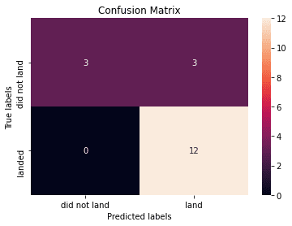

Figure : Calculate the accuracy on the test data using the method score:

Examining the confusion matrix, we see that logistic regression can distinguish between the different classes. We see that the major problem is false positives.

## TASK 6

**Create a support vector machine object then create a GridSearchCV object svm_cv with cv - 10. Fit the object to find the best parameters from the dictionary parameters**.

In [15]:

parameters **=** {'kernel':('linear', 'rbf','poly','rbf', 'sigmoid'),

'C': np**.**logspace(**-**3, 3, 5),

'gamma':np**.**logspace(**-**3, 3, 5)}

svm **=** SVC()

In [16]:

gs_cv **=** GridSearchCV(svm,parameters, scoring**=**'accuracy', cv**=**10)

svm_cv **=** gs_cv**.**fit(X_train, Y_train)

In [17]:

print("Tuned hpyerparameters :(best parameters) ", svm_cv**.**best_params_)

print("Accuracy for support vector machine:", svm_cv**.**best_score_)

Tuned hpyerparameters :(best parameters) {'C': 1.0, 'gamma': 0.03162277660168379, 'kernel': 'sigmoid'}

Accuracy for support vector machine: 0.8482142857142856

## TASK 7

**Calculate the accuracy on the test data using the method score:**

In [18]:

print("Accuracy for support vector machine on the test data using the method score:", svm_cv**.**score(X_test, Y_test))

Accuracy for support vector machine on the test data using the method score: 0.8333333333333334

We can plot the confusion matrix

In [19]:

yhat**=**svm_cv**.**predict(X_test)

plot_confusion_matrix(Y_test,yhat)



Figure : Calculate the accuracy on the test data using the method score:

## TASK 8

**Create a decision tree classifier object then create a GridSearchCV object tree_cv with cv = 10. Fit the object to find the best parameters from the dictionary parameters.**

In [20]:

parameters **=** {'criterion': ['gini', 'entropy'],

'splitter': ['best', 'random'],

'max_depth': [2**\***n **for** n **in** range(1,10)],

'max_features': ['auto', 'sqrt'],

'min_samples_leaf': [1, 2, 4],

'min_samples_split': [2, 5, 10]}

tree **=** DecisionTreeClassifier()

In [21]:

gs_cv **=** GridSearchCV(tree,parameters, scoring**=**'accuracy', cv**=**10)

tree_cv **=** gs_cv**.**fit(X_train, Y_train)

In [22]:

print("Tuned hpyerparameters :(best parameters) ", tree_cv**.**best_params_)

print("Accuracy for decision tree classifier:", tree_cv**.**best_score_)

Tuned hpyerparameters :(best parameters) {'criterion': 'gini', 'max_depth': 10, 'max_features': 'sqrt', 'min_samples_leaf': 1, 'min_samples_split': 2, 'splitter': 'best'}

Accuracy for decision tree classifier: 0.9017857142857144

## TASK 9

**Calculate the accuracy of tree_cv on the test data using the method score:**

In [23]:

print("Accuracy for decision tree classifier on the test data using the method score:", tree_cv**.**score(X_test, Y_test))

Accuracy for decision tree classifier on the test data using the method score: 0.8333333333333334

We can plot the confusion matrix

In [24]:

yhat **=** svm_cv**.**predict(X_test)

plot_confusion_matrix(Y_test, yhat)



Figure : Calculate the accuracy of tree_cv on the test data using the method score:

## TASK 10

**Create a k nearest neighbors object then create a GridSearchCV object knn_cv with cv = 10. Fit the object to find the best parameters from the dictionary parameters.**

In [25]:

parameters **=** {'n_neighbors': [1, 2, 3, 4, 5, 6, 7, 8, 9, 10],

'algorithm': ['auto', 'ball_tree', 'kd_tree', 'brute'],

'p': [1,2]}

KNN **=** KNeighborsClassifier()

In [26]:

gs_cv **=** GridSearchCV(KNN, parameters, scoring**=**'accuracy', cv**=**10)

knn_cv **=** gs_cv**.**fit(X_train, Y_train)

In [27]:

print("Tuned hpyerparameters :(best parameters) ",knn_cv**.**best_params_)

print("Accuracy for k nearest neighbors:",knn_cv**.**best_score_)

Tuned hpyerparameters :(best parameters) {'algorithm': 'auto', 'n_neighbors': 10, 'p': 1}

Accuracy for k nearest neighbors: 0.8482142857142858

## TASK 11

**Calculate the accuracy of tree_cv on the test data using the method score:**

In [28]:

print("Accuracy for k nearest neighbors on the test data using the method score: ",knn_cv**.**score(X_test, Y_test))

Accuracy for k nearest neighbors on the test data using the method score: 0.8333333333333334

We can plot the confusion matrix

In [29]:

yhat **=** knn_cv**.**predict(X_test)

plot_confusion_matrix(Y_test,yhat)



Figure : Calculate the accuracy of tree_cv on the test data using the method score:

## TASK 12

**Find the method performs best:**

In [30]:

algorithms **=** {'KNN':knn_cv**.**best_score_,'Decision Tree':tree_cv**.**best_score_,'Logistic Regression':logreg_cv**.**best_score_,'SVM':svm_cv**.**best_score_}

best_algorithm **=** max(algorithms, key**=** **lambda** x: algorithms[x])

print('The method which performs best is \"',best_algorithm,'\" with a score of',algorithms[best_algorithm])

The method which performs best is " Decision Tree " with a score of 0.9017857142857144

In [31]:

algo_df **=** pd**.**DataFrame**.**from_dict(algorithms, orient**=**'index', columns**=**['Accuracy'])

In [32]:

algo_df**.**head()

Out[32]:

Table : Find the method performs best:

|  | **Accuracy** |
| --- | --- |
| **KNN** | 0.848214 |
| **Decision Tree** | 0.901786 |
| **Logistic Regression** | 0.846429 |
| **SVM** | 0.848214 |

In [33]:

algo_df**.**sort_values(['Accuracy'], inplace**=True**)

In [34]:

algo_df**.**head()

Out[34]:

|  | **Accuracy** |
| --- | --- |
| **Logistic Regression** | 0.846429 |
| **SVM** | 0.848214 |
| **KNN** | 0.848214 |
| **Decision Tree** | 0.901786 |

In [35]:

algo_df **=** algo_df**.**reset_index()

algo_df**.**head()

Out[35]:

|  | **index** | **Accuracy** |
| --- | --- | --- |
| **0** | Logistic Regression | 0.846429 |
| **1** | SVM | 0.848214 |
| **2** | KNN | 0.848214 |
| **3** | Decision Tree | 0.901786 |

In [36]:

algo_df**.**rename(columns **=** {'index': 'Algorithm'}, inplace **=** **True**)

algo_df**.**head()

Out[36]:

|  | **Algorithm** | **Accuracy** |
| --- | --- | --- |
| **0** | Logistic Regression | 0.846429 |
| **1** | SVM | 0.848214 |
| **2** | KNN | 0.848214 |
| **3** | Decision Tree | 0.901786 |

In [37]:

**import** plotly.express **as** px

**import** plotly.graph_objects **as** go

In [38]:

fig **=** px**.**bar(algo_df, x**=**'Algorithm', y**=**'Accuracy', hover_data**=**['Algorithm', 'Accuracy'], color**=**'Accuracy', color_continuous_scale**=**'rdylbu')

fig**.**update_layout(title**=**'Algorithm vs. Accuracy', xaxis_title**=**'Algorithm', yaxis_title**=**'Accuracy' )

fig**.**show()

## Authors

[Joseph Santarcangelo](https://www.linkedin.com/in/joseph-s-50398b136/?utm_medium=Exinfluencer&utm_source=Exinfluencer&utm_content=000026UJ&utm_term=10006555&utm_id=NA-SkillsNetwork-Channel-SkillsNetworkCoursesIBMDS0321ENSkillsNetwork26802033-2021-01-01) has a PhD in Electrical Engineering, his research focused on using machine learning, signal processing, and computer vision to determine how videos impact human cognition. Joseph has been working for IBM since he completed his PhD.

## Change Log

Table : Week 4.1 Change Log

| **Date (YYYY-MM-DD)** | **Version** | **Changed By** | **Change Description** |
| --- | --- | --- | --- |
| 2020-09-20 | 1.0 | Joseph | Modified Multiple Areas |

## 5️⃣ Chapter 5: Present Your Data-Driven Insights

**5.1:** [**Present Your Data-Driven Insights with Presentation**](https://github.com/sachinrathi1997/SpaceX_DS_Project/blob/main/SpaceX%20Industrial%20Project%20PPT.pdf)

[](https://github.com/sachinrathi1997/SpaceX_DS_Project/blob/main/SpaceX%20Industrial%20Project.docx)

[Insights with Presentation](https://github.com/sachinrathi1997/SpaceX_DS_Project/blob/main/SpaceX%20Industrial%20Project.docx)

[](https://github.com/sachinrathi1997/SpaceX_DS_Project/blob/main/SpaceX%20Industrial%20Project%20PPT.pdf)

[Insights with Presentation](https://github.com/sachinrathi1997/SpaceX_DS_Project/blob/main/SpaceX%20Industrial%20Project%20PPT.pdf)

[](https://github.com/sachinrathi1997/SpaceX_DS_Project/blob/main/SpaceX%20Industrial%20Project%20PPT.pptx)

[Insights with Presentation](https://github.com/sachinrathi1997/SpaceX_DS_Project/blob/main/SpaceX%20Industrial%20Project%20PPT.pptx)

## 💫 Out of the Box Thinking

* Advanced Folium Function [Measurement Control Plugin with Folium](https://github.com/sachinrathi1997/SpaceX_DS_Project/blob/main/images/measurementcontrol.png)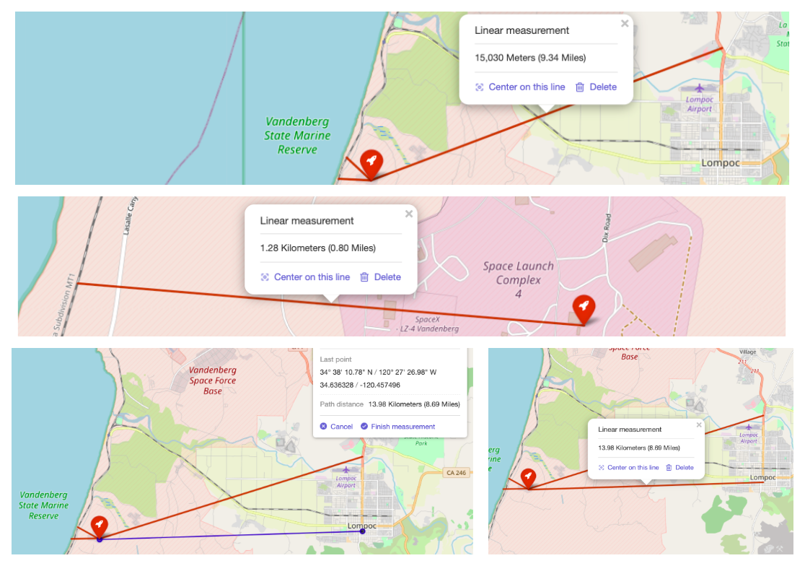

Insights with Presentation : measurementcontrol.png

* **Advanced Folium Function**[**Folium Custom Pane with Labels**](https://github.com/sachinrathi1997/SpaceX_DS_Project/blob/main/images/custompanes.png)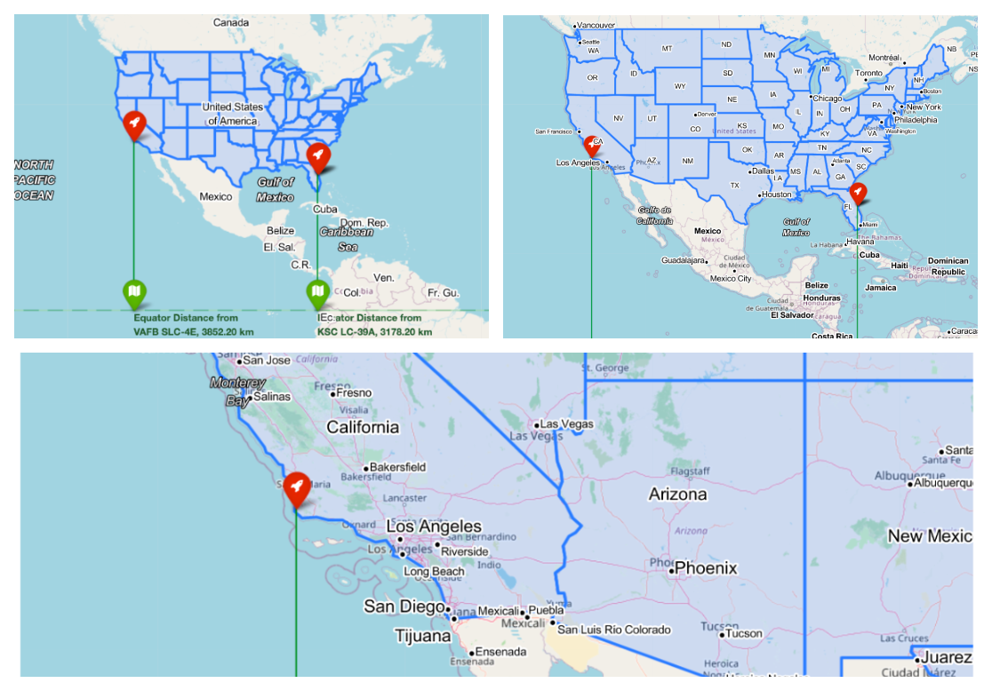

Insights with Presentation : custompanes.png

* [**Hosting the Plotly on "Python Anywhere" Server with Flask**](https://github.com/sachinrathi1997/SpaceX_DS_Project/blob/main/images/interactive-plotly.gif)

Insights with Presentation : interactive-plotly.gif

* [**Machine Learning - Decision Tree Construction**](https://github.com/sachinrathi1997/SpaceX_DS_Project/blob/main/images/decision-tree.png)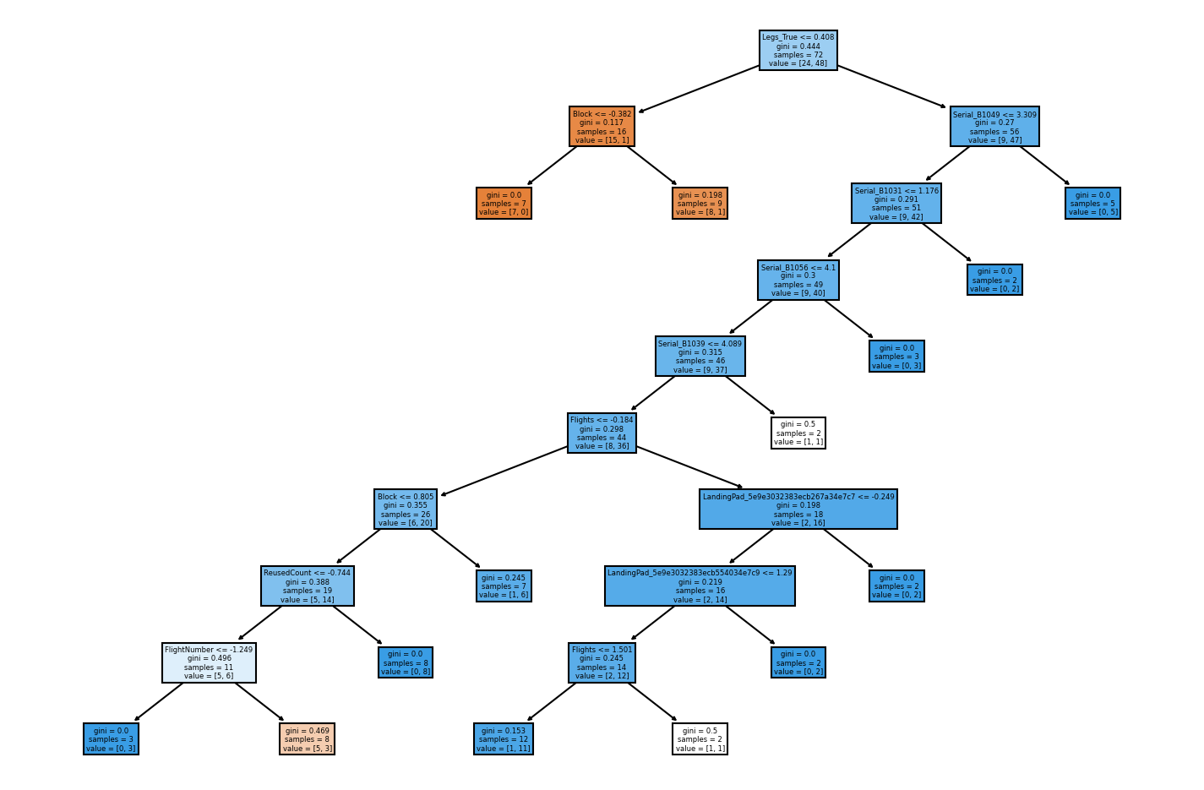

Insights with Presentation : decision-tree.png

* [**EDA Visualization with Interactive Plotly (Instead of Seaborn)**](https://github.com/sachinrathi1997/SpaceX_DS_Project/blob/main/images/plotly.png) 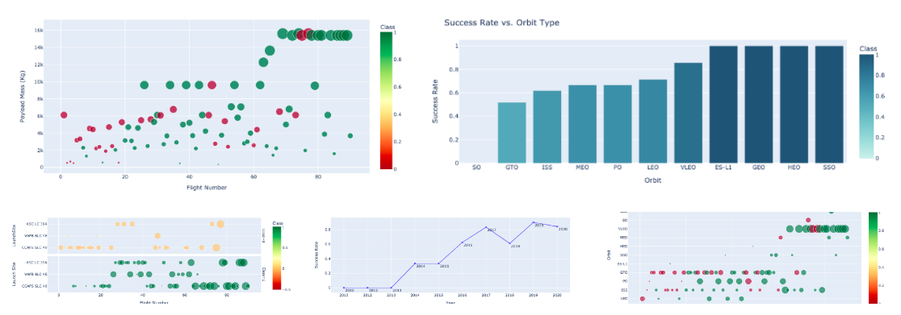

Insights with Presentation : plotly.png

* [**IBM Cognos Visualization with Player**](https://github.com/sachinrathi1997/SpaceX_DS_Project/blob/main/images/IBM-Cognos.png) [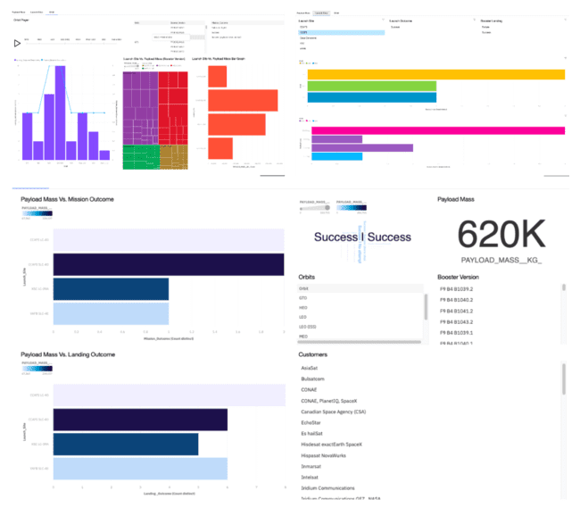](https://github.com/debdattasarkar/SpaceX-Data-Science-Project/blob/master/images/IBM-Cognos.png)

Insights with Presentation : IBM-Cognos.png

## ⛏️ Built With

* [Python](https://www.python.org/) - Programming Language
* [IBM Watson Studio](https://www.ibm.com/in-en/cloud/watson-studio) - IBM’s software platform for data science
* [IBM Db2](https://www.ibm.com/in-en/analytics/db2) - Db2 is a family of data management products, including database servers, developed by IBM
* [Jupiter Notebooks](https://jupyter.org/) - Open-source web application that allows data scientists to create and share documents that integrate live code, equations, computational output, visualizations, and other multimedia resources.
* [Anaconda](https://www.anaconda.com/) - Local environment for practice
* [pythonanywhere.com](https://www.pythonanywhere.com/) - Host your Python App via Flask
* [plotly.com](https://plotly.com/) - Plotly stewards Python's leading data viz and UI libraries. With Dash Open Source, Dash apps run on your local laptop or server
* [IBM Cognos Dashboard](https://www.ibm.com/docs/en/cognos-analytics/11.1.0?topic=stories-get-started-dashboards) - IBM Cognos Analytics provides dashboards and stories to communicate your insights and analysis. You can assemble a view that contains visualizations such as a graph, chart, plot, table, map, or any other visual representation of data.
* [GitHub](https://github.com/) - Repository for storing all files

## 📚 Extra Study Materials

Don’t jump into labs without study. Take time to study previous labs step by step and practice on your own laptop locally by installing Anaconda. This will also limit the usage of IBM Cloud Trial version.

* [Plotly](https://dash.plotly.com/layout)
* [Folium](https://python-visualization.github.io/folium/plugins.html)
* [Folium Examples](https://nbviewer.jupyter.org/github/python-visualization/folium/tree/master/examples/)
* [Confusion Matrix](https://www.dataschool.io/simple-guide-to-confusion-matrix-terminology/)

//use correct references

//include chapter 2 as literature review

//correct chapter headings

[**References:**](https://econsortium.aktu.ac.in/)

* [Hands-on Lab: String Patterns, Sorting and Grouping](https://cf-courses-data.s3.us.cloud-object-storage.appdomain.cloud/IBMDeveloperSkillsNetwork-DB0201EN-SkillsNetwork/labs/Labs_Coursera_V5/labs/Lab%20-%20String%20Patterns%20-%20Sorting%20-%20Grouping/instructional-labs.md.html?utm_medium=Exinfluencer&utm_source=Exinfluencer&utm_content=000026UJ&utm_term=10006555&utm_id=NA-SkillsNetwork-Channel-SkillsNetworkCoursesIBMDS0321ENSkillsNetwork26802033-2021-01-01&origin=www.coursera.org)
* [Hands-on Lab: Built-in functions](https://cf-courses-data.s3.us.cloud-object-storage.appdomain.cloud/IBMDeveloperSkillsNetwork-DB0201EN-SkillsNetwork/labs/Labs_Coursera_V5/labs/Lab%20-%20Built-in%20functions%20/Hands-on_Lab__Built-in_Functions.md.html?utm_medium=Exinfluencer&utm_source=Exinfluencer&utm_content=000026UJ&utm_term=10006555&utm_id=NA-SkillsNetwork-Channel-SkillsNetworkCoursesIBMDS0321ENSkillsNetwork26802033-2021-01-01&origin=www.coursera.org)
* [Hands-on Lab: Sub-queries and Nested SELECT Statements](https://cf-courses-data.s3.us.cloud-object-storage.appdomain.cloud/IBMDeveloperSkillsNetwork-DB0201EN-SkillsNetwork/labs/Labs_Coursera_V5/labs/Lab%20-%20Sub-queries%20and%20Nested%20SELECTs%20/instructional-labs.md.html?utm_medium=Exinfluencer&utm_source=Exinfluencer&utm_content=000026UJ&utm_term=10006555&utm_id=NA-SkillsNetwork-Channel-SkillsNetworkCoursesIBMDS0321ENSkillsNetwork26802033-2021-01-01&origin=www.coursera.org)
* [Hands-on Tutorial: Accessing Databases with SQL magic](https://cf-courses-data.s3.us.cloud-object-storage.appdomain.cloud/IBMDeveloperSkillsNetwork-DB0201EN-SkillsNetwork/labs/Module%205/DB0201EN-Week3-1-3-SQLmagic.ipynb?utm_medium=Exinfluencer&utm_source=Exinfluencer&utm_content=000026UJ&utm_term=10006555&utm_id=NA-SkillsNetwork-Channel-SkillsNetworkCoursesIBMDS0321ENSkillsNetwork26802033-2021-01-01)
* [Hands-on Lab: Analysing a real-World Data Set](https://cf-courses-data.s3.us.cloud-object-storage.appdomain.cloud/IBMDeveloperSkillsNetwork-DB0201EN-SkillsNetwork/labs/Module%205/DB0201EN-Week3-1-4-Analyzing.ipynb?utm_medium=Exinfluencer&utm_source=Exinfluencer&utm_content=000026UJ&utm_term=10006555&utm_id=NA-SkillsNetwork-Channel-SkillsNetworkCoursesIBMDS0321ENSkillsNetwork26802033-2021-01-01)
* [Joseph Santarcangelo](https://www.linkedin.com/in/joseph-s-50398b136/?utm_medium=Exinfluencer&utm_source=Exinfluencer&utm_content=000026UJ&utm_term=10006555&utm_id=NA-SkillsNetwork-Channel-SkillsNetworkCoursesIBMDS0321ENSkillsNetwork26802033-2021-01-01) has a PhD in Electrical Engineering, his research focused on using machine learning, signal processing, and computer vision to determine how videos impact human cognition. Joseph has been working for IBM since he completed his PhD.
* [Yan Luo](https://www.linkedin.com/in/yan-luo-96288783/?utm_medium=Exinfluencer&utm_source=Exinfluencer&utm_content=000026UJ&utm_term=10006555&utm_id=NA-SkillsNetwork-Channel-SkillsNetworkCoursesIBMDS0321ENSkillsNetwork26802033-2021-01-01)
* [Nayef Abou Tayoun](https://www.linkedin.com/in/nayefaboutayoun/?utm_medium=Exinfluencer&utm_source=Exinfluencer&utm_content=000026UJ&utm_term=10006555&utm_id=NA-SkillsNetwork-Channel-SkillsNetworkCoursesIBMDS0321ENSkillsNetwork26802033-2021-01-01)
* [Joseph Santarcangelo](https://www.linkedin.com/in/joseph-s-50398b136/?utm_medium=Exinfluencer&utm_source=Exinfluencer&utm_content=000026UJ&utm_term=10006555&utm_id=NA-SkillsNetwork-Channel-SkillsNetworkCoursesIBMDS0321ENSkillsNetwork26802033-2021-01-01) has a PhD in Electrical Engineering, his research focused on using machine learning, signal processing, and computer vision to determine how videos impact human cognition. Joseph has been working for IBM since he completed his PhD.
* [Nayef Abou Tayoun](https://www.linkedin.com/in/nayefaboutayoun/?utm_medium=Exinfluencer&utm_source=Exinfluencer&utm_content=000026UJ&utm_term=10006555&utm_id=NA-SkillsNetwork-Channel-SkillsNetworkCoursesIBMDS0321ENSkillsNetwork26802033-2021-01-01) is a Data Scientist at IBM and pursuing a Master of Management in Artificial intelligence degree at Queen's University.
* Iztok Fajfar “Start Programming Using HTML,CSS and JavaScript” issue 21 October 2015 Pub. Location New York.
* Preston Zhang “Practical Guide to Oracle SQL,T-SQL and MySQL” issue 21 November 2017 Pub. Location Boca Raton
* Mitsunori Ogihara “Fundamentals of Java Programming” issue 25 January 2016 Pub. Springe,Cham
* Richard Wiener “Fundamentals of OOP and Data Structures in Java” issue on June 2012 Pub. Cambridge University Press.
* Dr. Geeta Sharma, “Study of Internet Banking Scenario in India”,International Journal of Emerging Research in Management &Technology, ISSN: 2278-9359, Volume 5, Issue 5, 2016, pp.43-48.
* Anju Dagar, “Online Banking : Benefits and Related Issues”, International Journal of Commerce, Business and Management (IJCBM), ISSN: 2319–2828,Vol. 3, No. 5, 2014,pp.715-719.
* Ebubeogu Amarachukwu Felix, “ Bank Customers Management System”,International Journal of Scientific & Technology Research Volume 4, Issue 08, 2015, pp.326- 343.

